**DAA lab programs**

1. **C program to print Fibonacci series using recursion.**

#include <stdio.h>

int fibonacci(int n) {

if (n <= 1)

return n;

return fibonacci(n - 1) + fibonacci(n - 2);

}

int main() {

int n, i;

printf("Enter the number of terms: ");

scanf ("%d", &n);

printf("Fibonacci Series: ");

for (i = 0; i < n; i++) {

printf("%d ", fibonacci(i));

}

return 0;

}

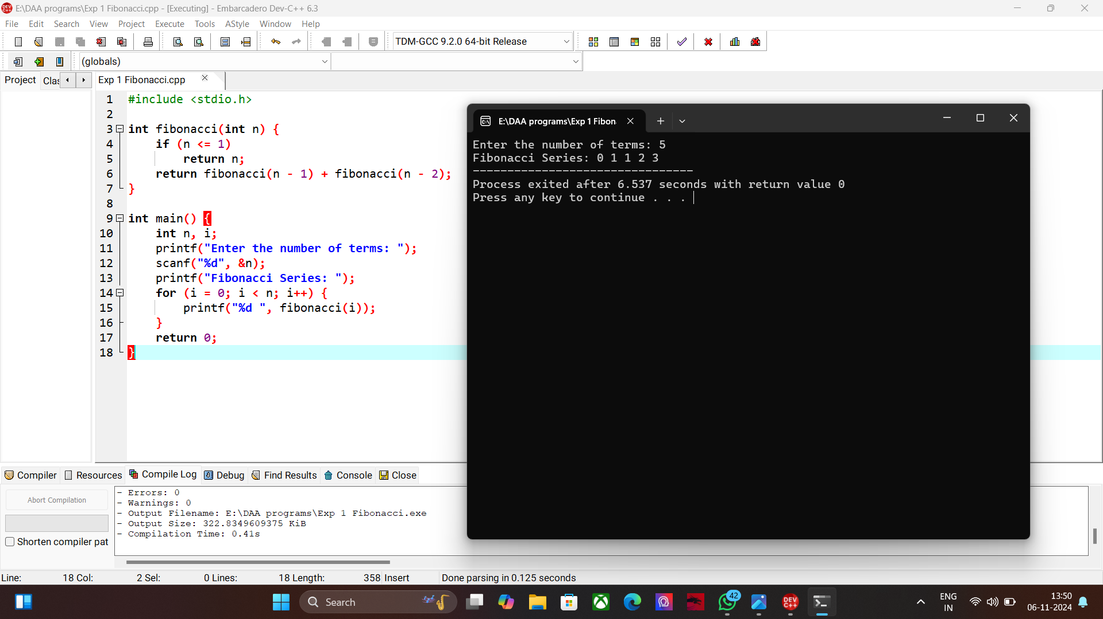

1. **C program to check the given number is Armstrong or not.**

#include <stdio.h>

#include <math.h>

int isArmstrong(int num) {

int originalNum, remainder, result = 0, n = 0;

originalNum = num;

while (originalNum != 0) {

originalNum /= 10;

++n;

}

originalNum = num;

while (originalNum != 0) {

remainder = originalNum % 10;

result += pow(remainder, n);

originalNum /= 10;

}

return result == num;

}

int main() {

int num;

printf("Enter an integer: ");

scanf("%d", &num);

if (isArmstrong(num))

printf("%d is an Armstrong number.\n", num);

else

printf("%d is not an Armstrong number.\n", num);

return 0;

}

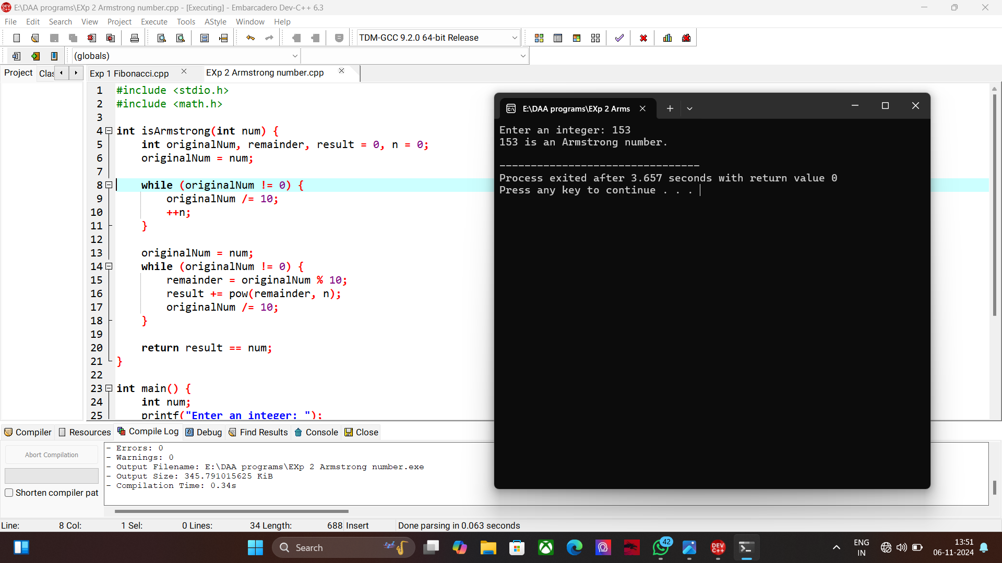

1. **C program to find the GCD of two numbers.**

#include <stdio.h>

int gcd(int a, int b) {

if (b == 0)

return a;

return gcd(b, a % b);

}

int main() {

int num1, num2;

printf("Enter two numbers: ");

scanf("%d %d", &num1, &num2);

printf("GCD of %d and %d is %d\n", num1, num2, gcd(num1, num2));

return 0;

}



1. **C program to get the largest element of an array.**

#include <stdio.h>

int main() {

int n, i;

printf("Enter the number of elements: ");

scanf("%d", &n);

int arr[n];

printf("Enter the elements:\n");

for (i = 0; i < n; i++) {

scanf("%d", &arr[i]);

}

int max = arr[0];

for (i = 1; i < n; i++) {

if (arr[i] > max) {

max = arr[i];

}

}

printf("Largest element is %d\n", max);

return 0;

}

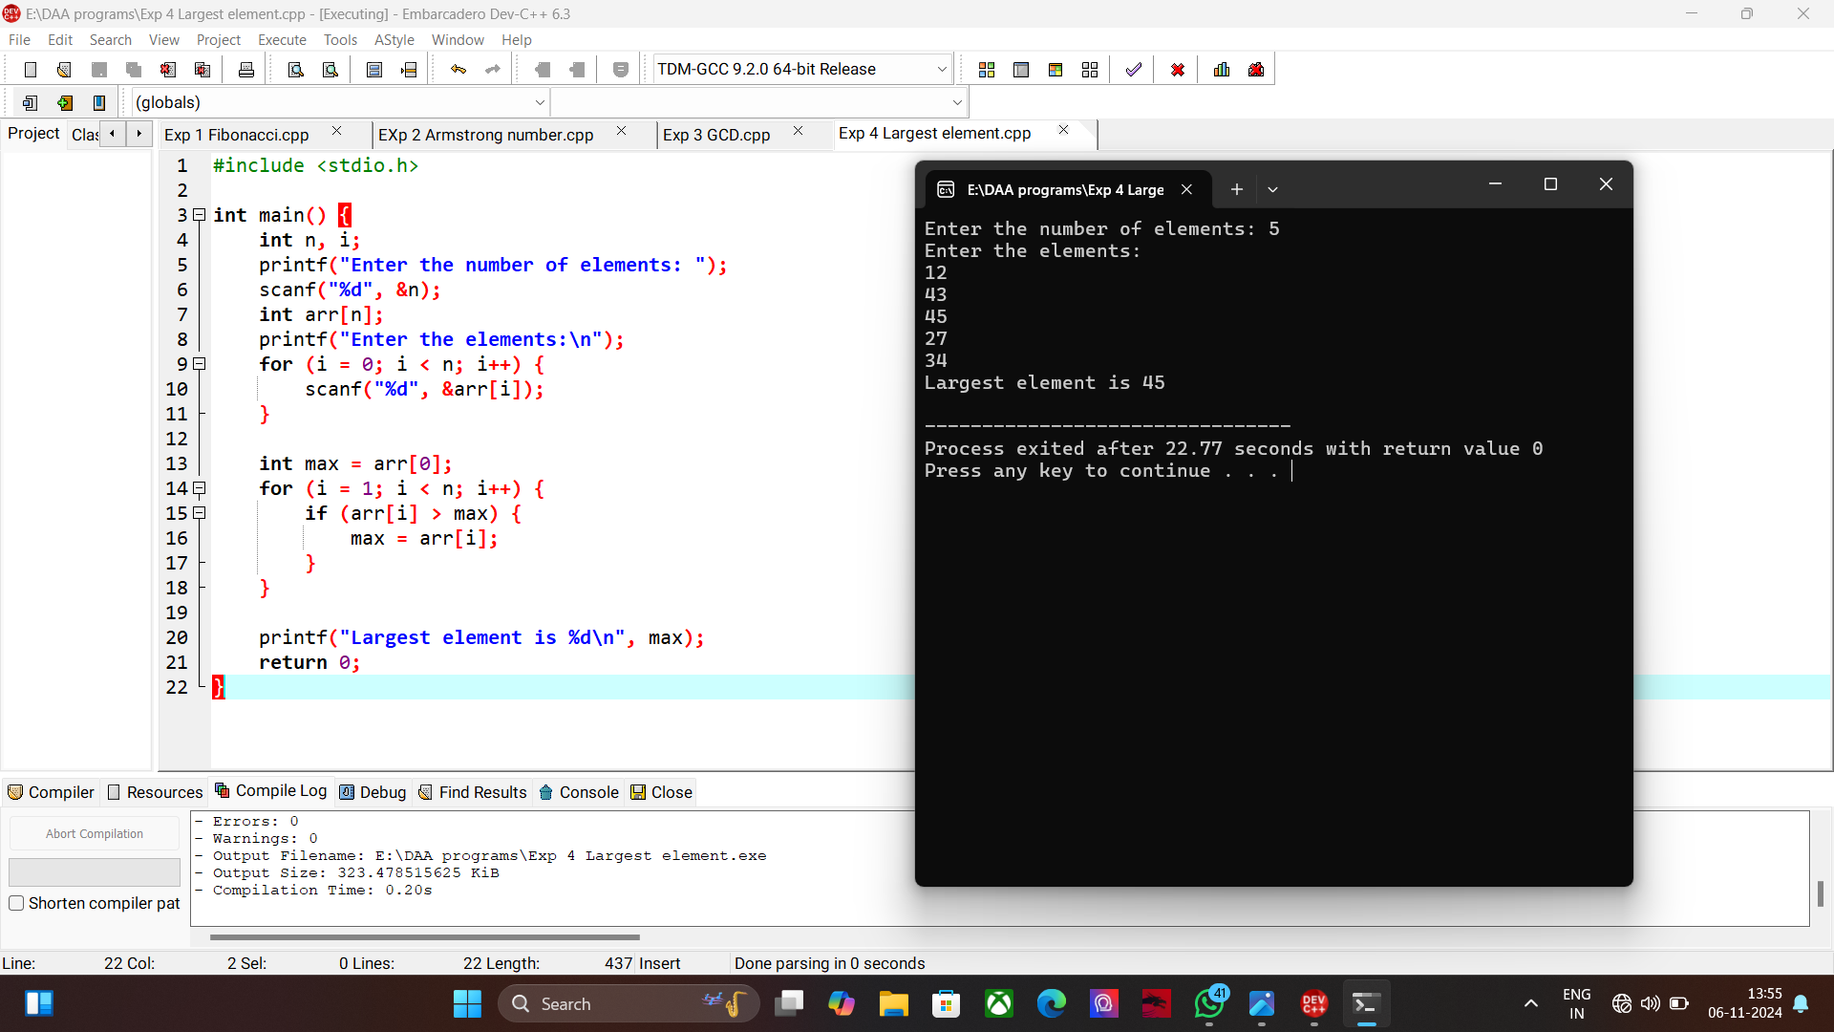

1. **C program to find the factorial of a number.**

#include <stdio.h>

long long factorial(int n) {

if (n == 0 || n == 1)

return 1;

return n * factorial(n - 1);

}

int main() {

int n;

printf("Enter a number: ");

scanf("%d", &n);

printf("Factorial of %d is %lld\n", n, factorial(n));

return 0;

}



1. **C program to check a number is prime or not.**

#include <stdio.h>

int isPrime(int n) {

if (n <= 1)

return 0;

for (int i = 2; i * i <= n; i++) {

if (n % i == 0)

return 0;

}

return 1;

}

int main() {

int n;

printf("Enter a number: ");

scanf("%d", &n);

if (isPrime(n))

printf("%d is a prime number.\n", n);

else

printf("%d is not a prime number.\n", n);

return 0;

}

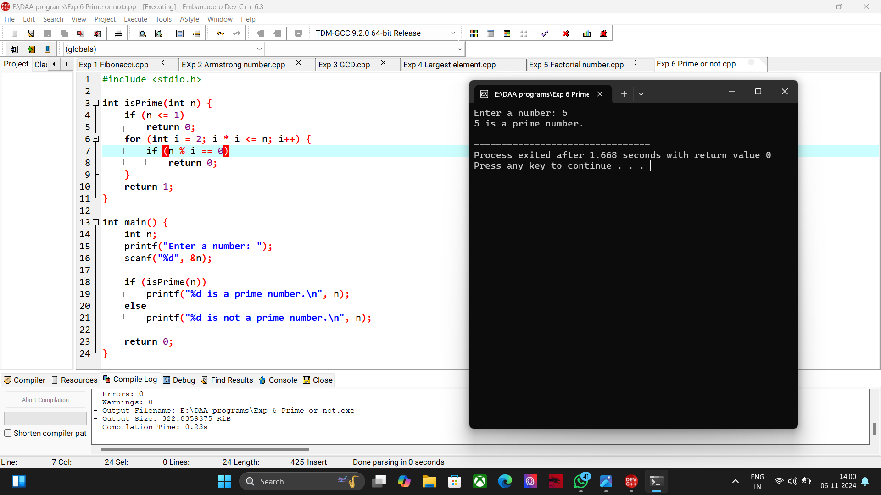

1. **Program to Perform Selection Sort**

#include <stdio.h>

void selectionSort(int arr[], int n) {

for (int i = 0; i < n - 1; i++) {

int minIndex = i;

for (int j = i + 1; j < n; j++) {

if (arr[j] < arr[minIndex]) {

minIndex = j;

}

}

int temp = arr[minIndex];

arr[minIndex] = arr[i];

arr[i] = temp;

}

}

int main() {

int arr[] = {64, 25, 12, 22, 11};

int n = sizeof(arr) / sizeof(arr[0]);

selectionSort(arr, n);

printf("Sorted array: ");

for (int i = 0; i < n; i++) {

printf("%d ", arr[i]);

}

printf("\n");

return 0;

}

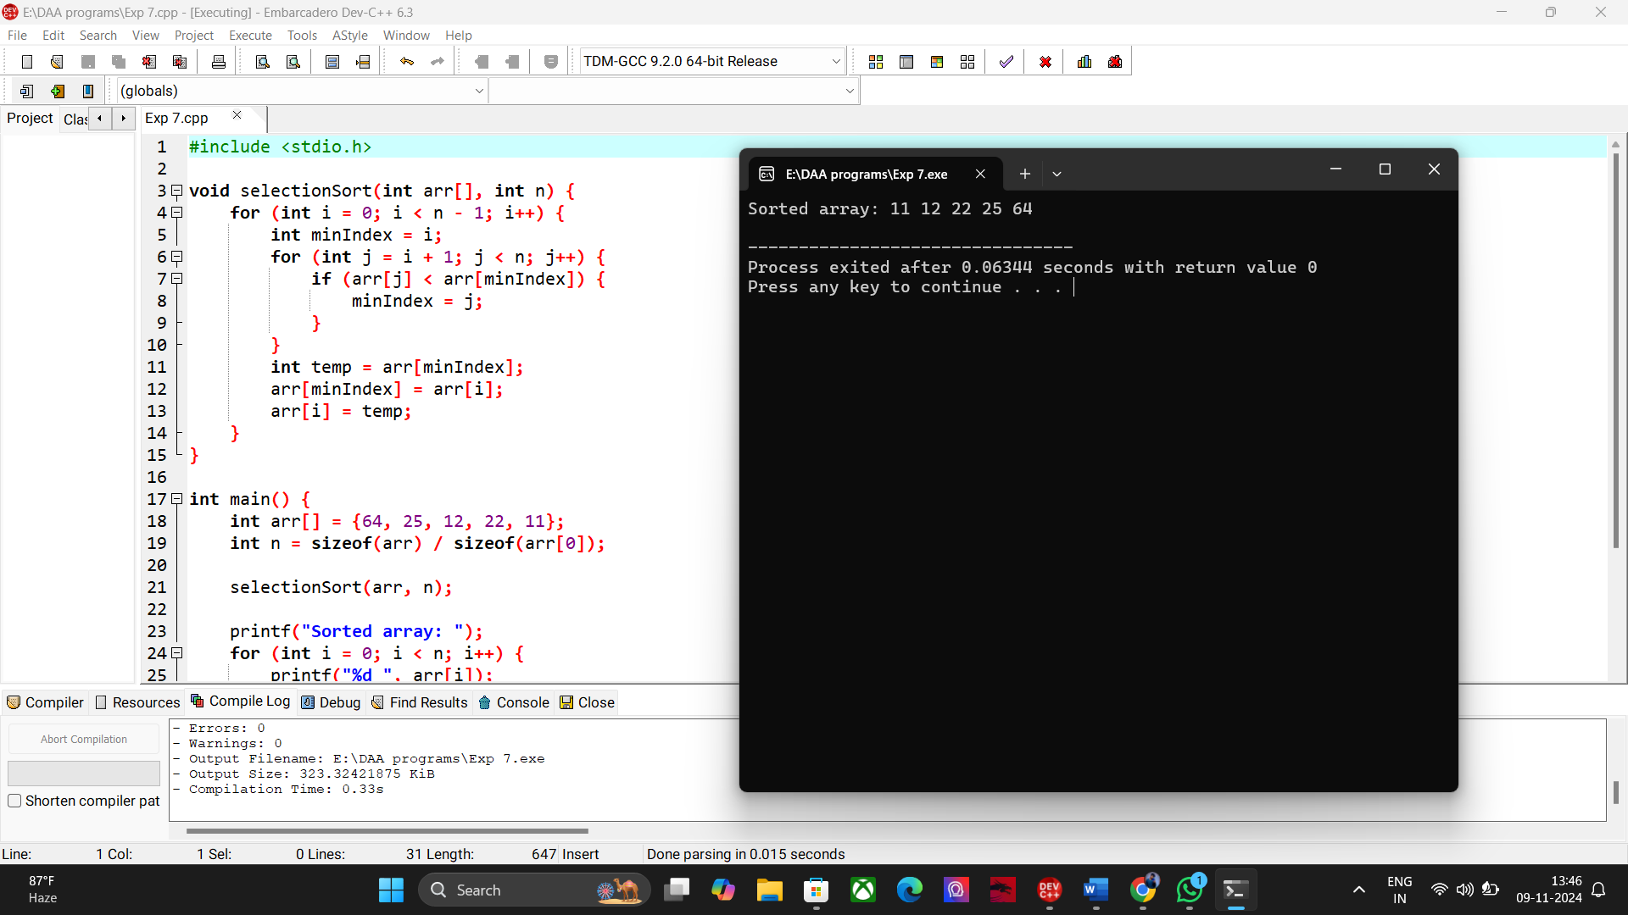

8. Program to Perform Bubble Sort  
  
#include <stdio.h>

void bubbleSort(int arr[], int n) {

for (int i = 0; i < n - 1; i++) {

for (int j = 0; j < n - i - 1; j++) {

if (arr[j] > arr[j + 1]) {

// Swap elements

int temp = arr[j];

arr[j] = arr[j + 1];

arr[j + 1] = temp;

}

}

}

}

int main() {

int arr[] = {64, 34, 25, 12, 22, 11, 90};

int n = sizeof(arr) / sizeof(arr[0]);

bubbleSort(arr, n);

printf("Sorted array: ");

for (int i = 0; i < n; i++) {

printf("%d ", arr[i]);

}

printf("\n");

return 0;

}

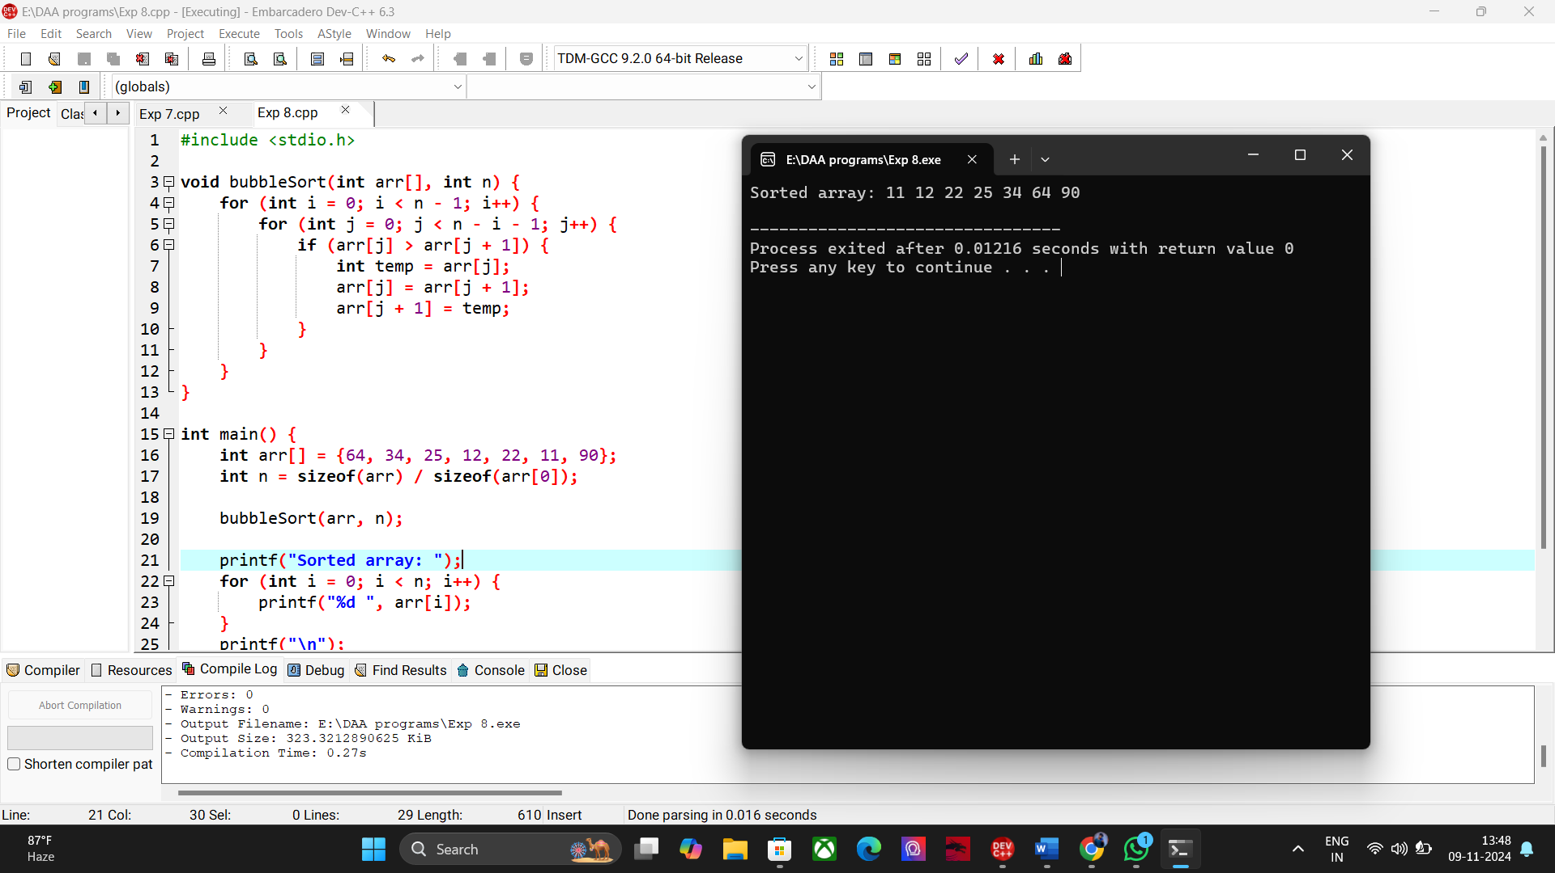

9. Program to Multiply Two Matrices  
  
#include <stdio.h>

void multiplyMatrices(int firstMatrix[][3], int secondMatrix[][3], int result[][3], int row, int col) {

for (int i = 0; i < row; i++) {

for (int j = 0; j < col; j++) {

result[i][j] = 0;

for (int k = 0; k < col; k++) {

result[i][j] += firstMatrix[i][k] * secondMatrix[k][j];

}

}

}

}

int main() {

int firstMatrix[3][3] = {{1, 2, 3}, {4, 5, 6}, {7, 8, 9}};

int secondMatrix[3][3] = {{9, 8, 7}, {6, 5, 4}, {3, 2, 1}};

int result[3][3];

int row = 3, col = 3;

multiplyMatrices(firstMatrix, secondMatrix, result, row, col);

printf("Product of the matrices:\n");

for (int i = 0; i < row; i++) {

for (int j = 0; j < col; j++) {

printf("%d ", result[i][j]);

}

printf("\n");

}

return 0;

}

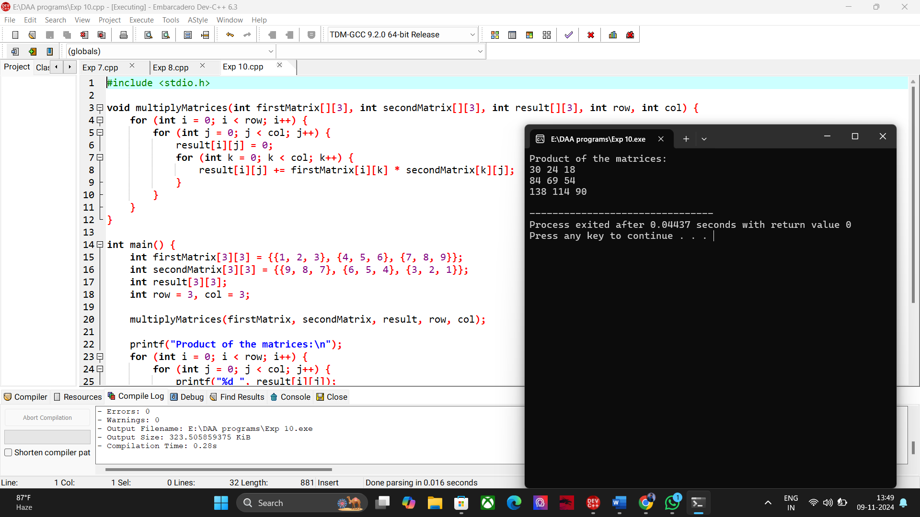

10. Program to Check if a String is a Palindrome  
  
#include <stdio.h>

#include <string.h>

int isPalindrome(char str[]) {

int len = strlen(str);

for (int i = 0; i < len / 2; i++) {

if (str[i] != str[len - i - 1]) {

return 0;

}

}

return 1;

}

int main() {

char str[100];

printf("Enter a string: ");

scanf("%s", str);

if (isPalindrome(str)) {

printf("The string is a palindrome.\n");

} else {

printf("The string is not a palindrome.\n");

}

return 0;

}



11. Program to Copy One String to Another Without strcpy  
  
#include <stdio.h>

void copyString(char *source, char *destination) {

while (*source) {

*destination = *source;

source++;

destination++;

}

*destination = '\0'; // Null-terminate the destination string

}

int main() {

char source[100], destination[100];

printf("Enter the source string: ");

scanf("%s", source);

copyString(source, destination);

printf("Copied string: %s\n", destination);

return 0;

}

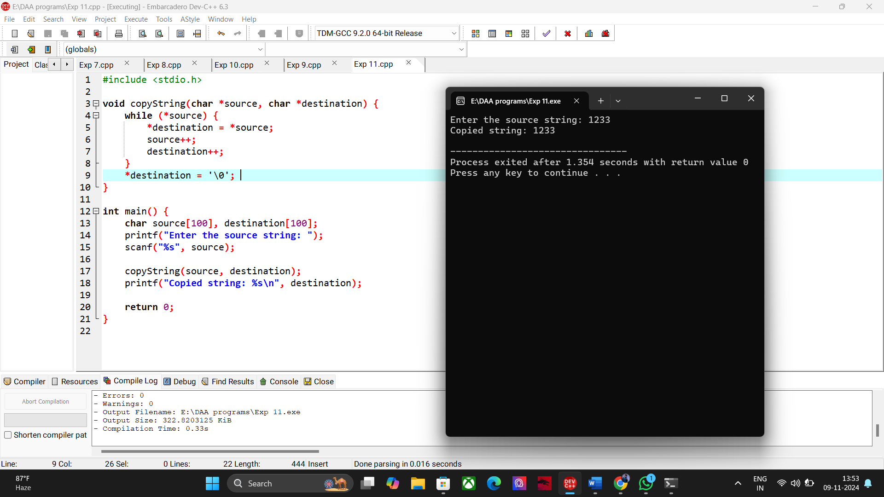

12. Program to Perform Binary Search  
  
#include <stdio.h>

int binarySearch(int arr[], int n, int key) {

int left = 0, right = n - 1;

while (left <= right) {

int mid = left + (right - left) / 2;

if (arr[mid] == key) return mid;

if (arr[mid] < key) left = mid + 1;

else right = mid - 1;

}

return -1;

}

int main() {

int arr[] = {2, 3, 4, 10, 40};

int n = sizeof(arr) / sizeof(arr[0]);

int key = 10;

int result = binarySearch(arr, n, key);

if (result != -1) printf("Element found at index: %d\n", result);

else printf("Element not found\n");

return 0;

}

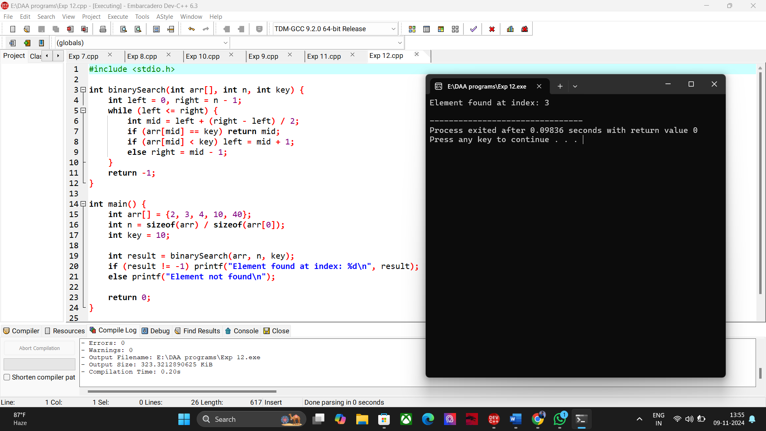

13. Program to Print Reverse of a String Without Using strrev  
  
#include <stdio.h>

#include <string.h>

void reverseString(char str[]) {

int len = strlen(str);

for (int i = len - 1; i >= 0; i--) {

printf("%c", str[i]);

}

printf("\n");

}

int main() {

char str[100];

printf("Enter a string: ");

scanf("%s", str);

printf("Reversed string: ");

reverseString(str);

return 0;

}

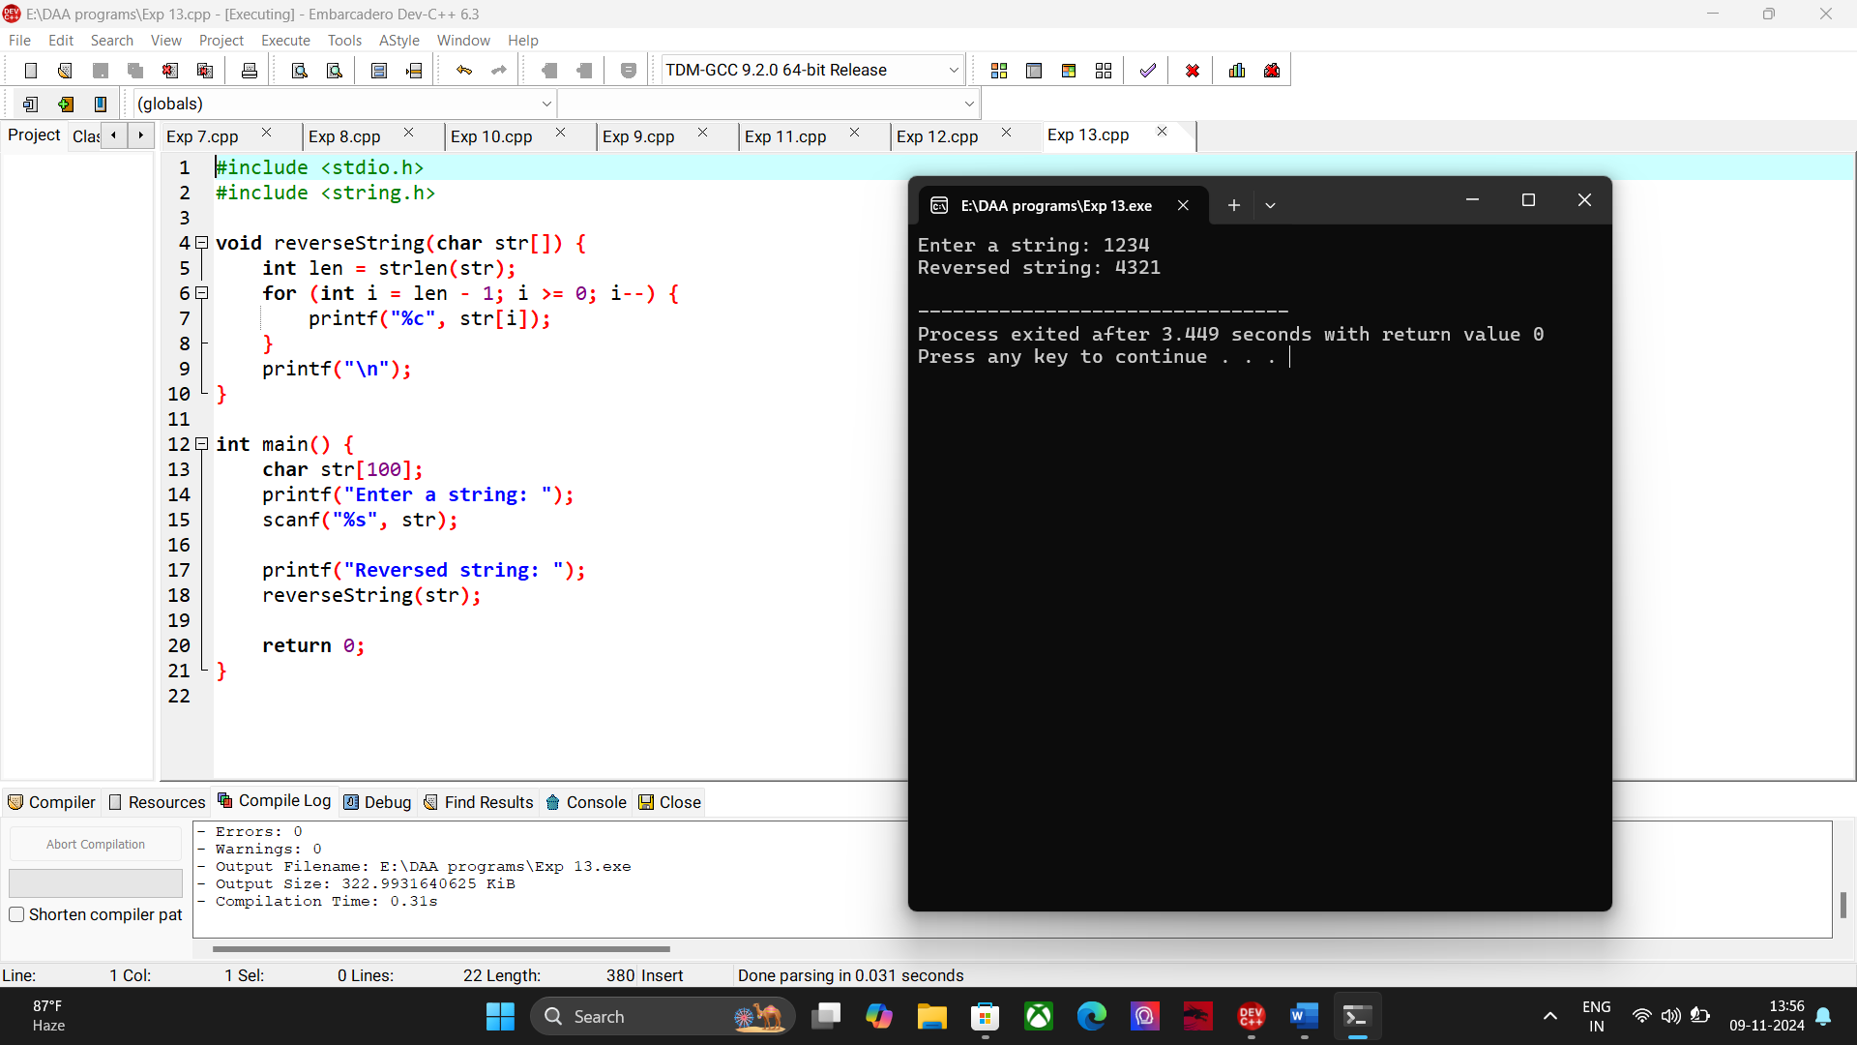

14. Program to Find the Length of a String  
  
#include <stdio.h>

int main() {

char str[100];

int length = 0;

printf("Enter a string: ");

gets(str);

// Calculate the length

while (str[length] != '\0') {

length++;

}

printf("Length of the string: %d\n", length);

return 0;

}

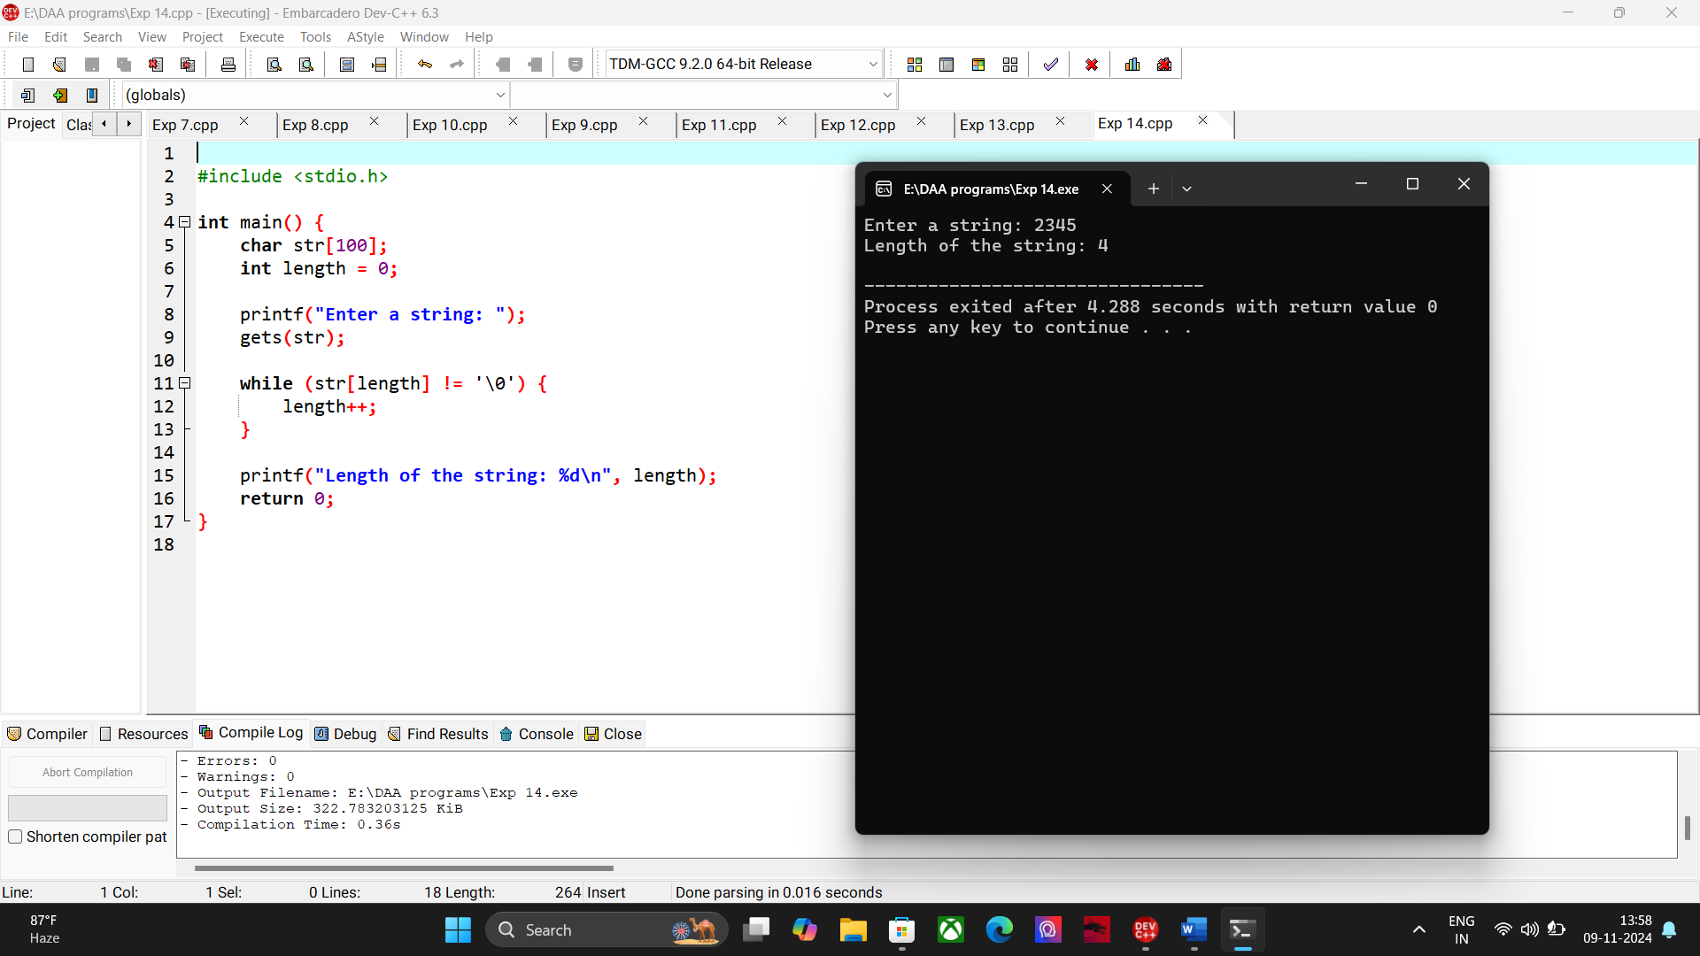

15. Perform Strassen's Matrix Multiplication

#include <stdio.h>

void multiplyMatrices(int A[2][2], int B[2][2], int C[2][2]) {

int M1, M2, M3, M4, M5, M6, M7;

M1 = (A[0][0] + A[1][1]) * (B[0][0] + B[1][1]);

M2 = (A[1][0] + A[1][1]) * B[0][0];

M3 = A[0][0] * (B[0][1] - B[1][1]);

M4 = A[1][1] * (B[1][0] - B[0][0]);

M5 = (A[0][0] + A[0][1]) * B[1][1];

M6 = (A[1][0] - A[0][0]) * (B[0][0] + B[0][1]);

M7 = (A[0][1] - A[1][1]) * (B[1][0] + B[1][1]);

C[0][0] = M1 + M4 - M5 + M7;

C[0][1] = M3 + M5;

C[1][0] = M2 + M4;

C[1][1] = M1 - M2 + M3 + M6;

}

int main() {

int A[2][2] = {{1, 2}, {3, 4}};

int B[2][2] = {{5, 6}, {7, 8}};

int C[2][2];

multiplyMatrices(A, B, C);

printf("Resultant Matrix:\n");

for (int i = 0; i < 2; i++) {

for (int j = 0; j < 2; j++) {

printf("%d ", C[i][j]);

}

printf("\n");

}

return 0;

}

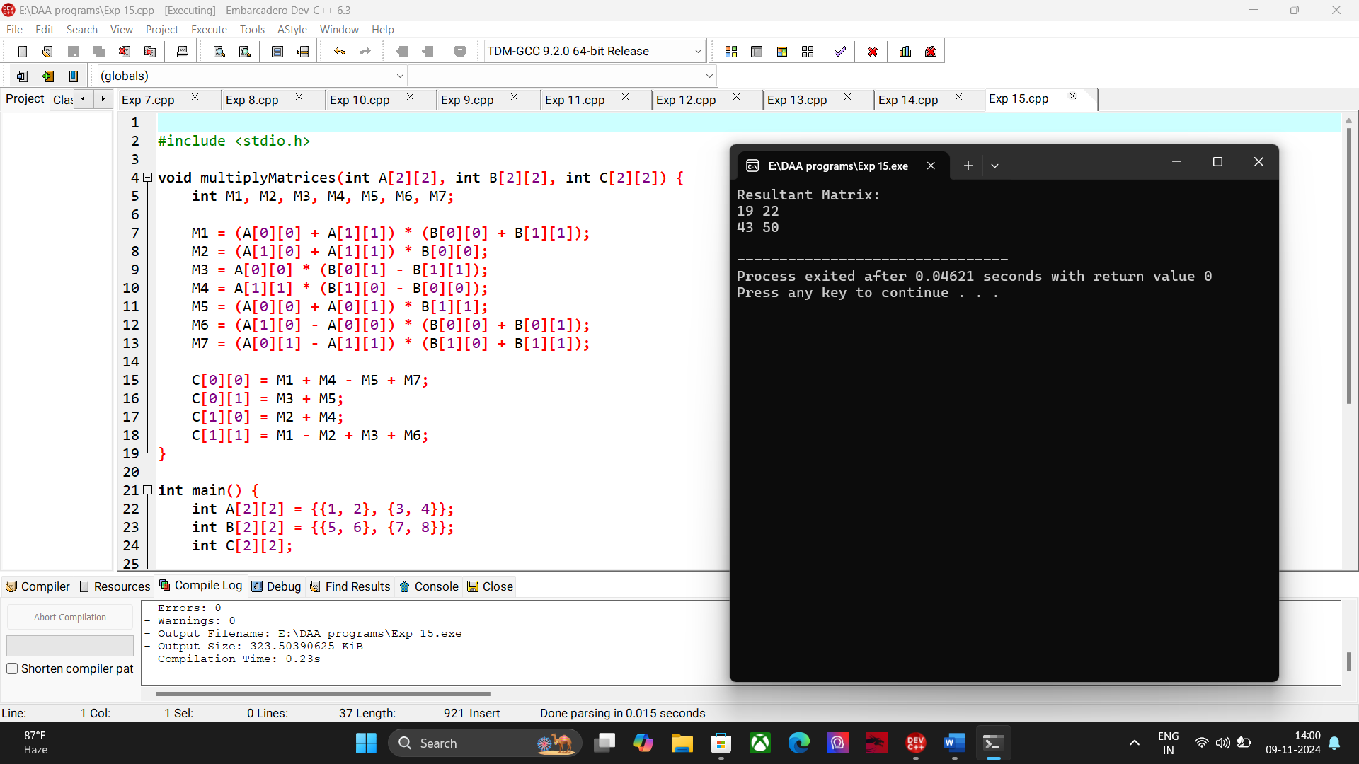

16. Merge Sort  
  
#include <stdio.h>

void merge(int arr[], int left, int mid, int right) {

int n1 = mid - left + 1;

int n2 = right - mid;

int L[n1], R[n2];

for (int i = 0; i < n1; i++)

L[i] = arr[left + i];

for (int j = 0; j < n2; j++)

R[j] = arr[mid + 1 + j];

int i = 0, j = 0, k = left;

while (i < n1 && j < n2) {

if (L[i] <= R[j]) {

arr[k] = L[i];

i++;

} else {

arr[k] = R[j];

j++;

}

k++;

}

while (i < n1) {

arr[k] = L[i];

i++;

k++;

}

while (j < n2) {

arr[k] = R[j];

j++;

k++;

}

}

void mergeSort(int arr[], int left, int right) {

if (left < right) {

int mid = left + (right - left) / 2;

mergeSort(arr, left, mid);

mergeSort(arr, mid + 1, right);

merge(arr, left, mid, right);

}

}

int main() {

int arr[] = {12, 11, 13, 5, 6, 7};

int arr_size = sizeof(arr) / sizeof(arr[0]);

printf("Unsorted array: ");

for (int i = 0; i < arr_size; i++)

printf("%d ", arr[i]);

printf("\n");

mergeSort(arr, 0, arr_size - 1);

printf("Sorted array: ");

for (int i = 0; i < arr_size; i++)

printf("%d ", arr[i]);

printf("\n");

return 0;

}  
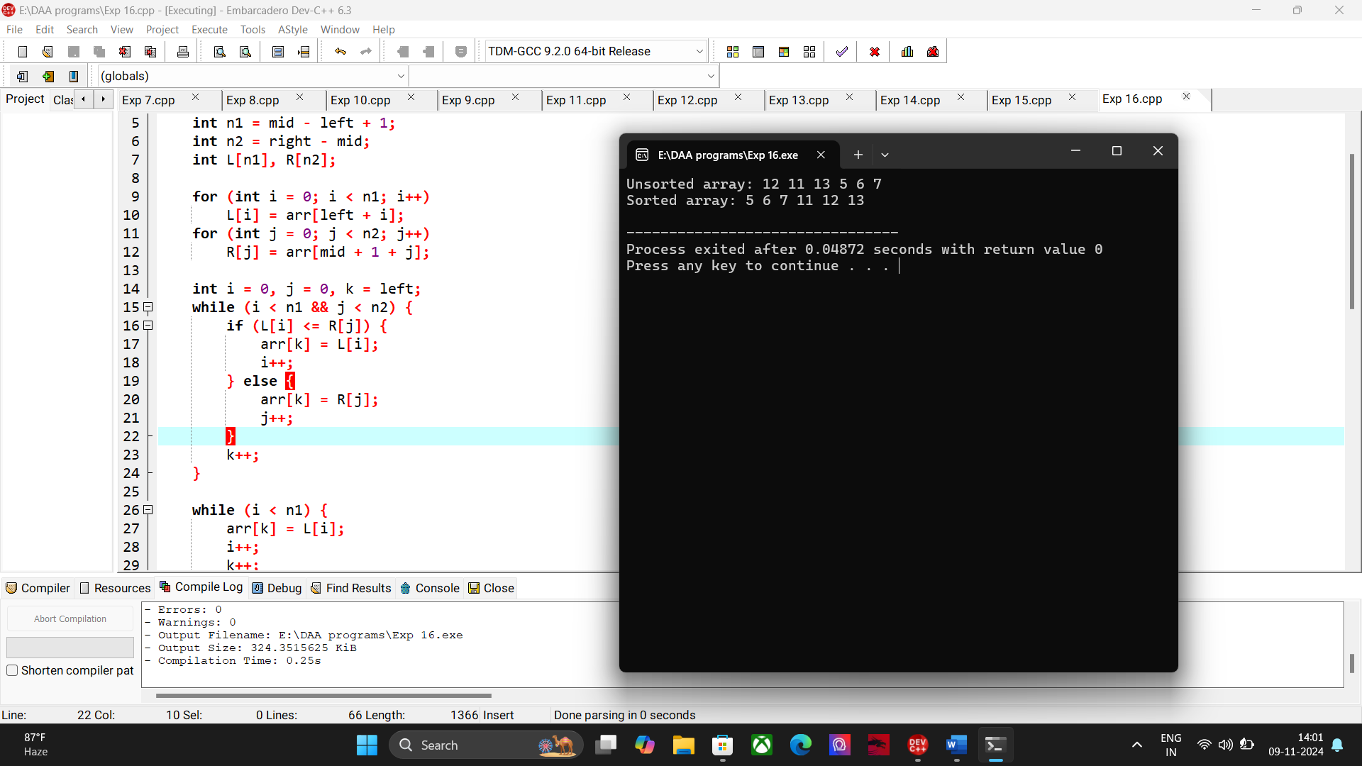

**17. Find Max and Min Using Divide and Conquer**

#include <stdio.h>

struct Result {

int max;

int min;

};

struct Result findMinMax(int arr[], int low, int high) {

struct Result result, leftResult, rightResult;

if (low == high) {

result.max = arr[low];

result.min = arr[low];

return result;

}

if (high == low + 1) {

if (arr[low] > arr[high]) {

result.max = arr[low];

result.min = arr[high];

} else {

result.max = arr[high];

result.min = arr[low];

}

return result;

}

int mid = (low + high) / 2;

leftResult = findMinMax(arr, low, mid);

rightResult = findMinMax(arr, mid + 1, high);

result.max = (leftResult.max > rightResult.max) ? leftResult.max : rightResult.max;

result.min = (leftResult.min < rightResult.min) ? leftResult.min : rightResult.min;

return result;

}

int main() {

int arr[] = {1, 3, 5, 2, 4, 8, 7};

int n = sizeof(arr) / sizeof(arr[0]);

struct Result result = findMinMax(arr, 0, n - 1);

printf("Maximum: %d\n", result.max);

printf("Minimum: %d\n", result.min);

return 0;

}

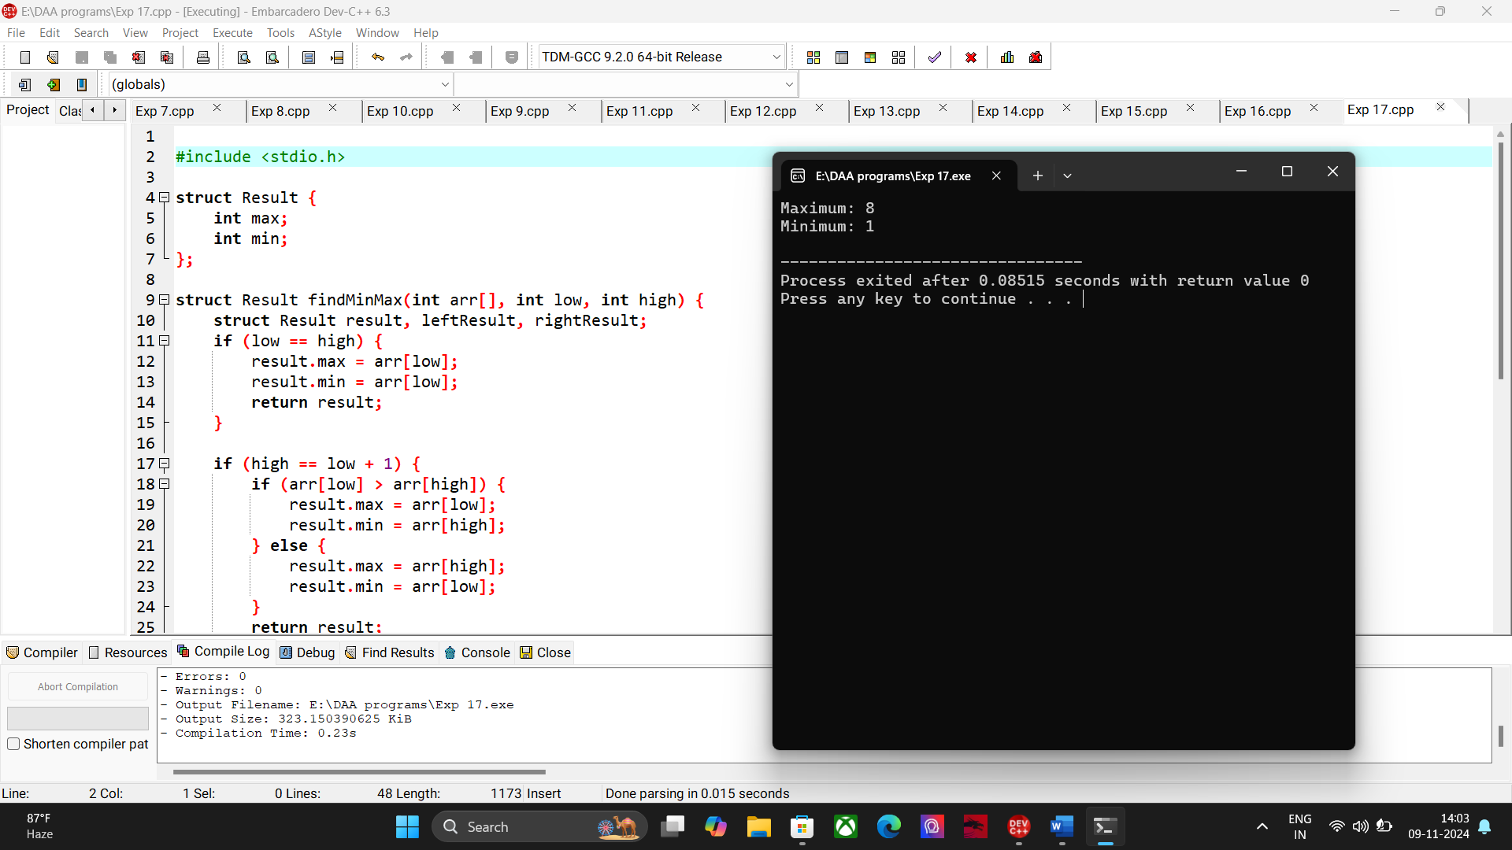

**18. Generate All Prime Numbers Between 1 and 100**  
#include <stdio.h>

int isPrime(int num) {

if (num < 2) return 0;

for (int i = 2; i * i <= num; i++) {

if (num % i == 0)

return 0;

}

return 1;

}

int main() {

printf("Prime numbers between 1 and 100 are:\n");

for (int i = 1; i <= 100; i++) {

if (isPrime(i))

printf("%d ", i);

}

printf("\n");

return 0;

}

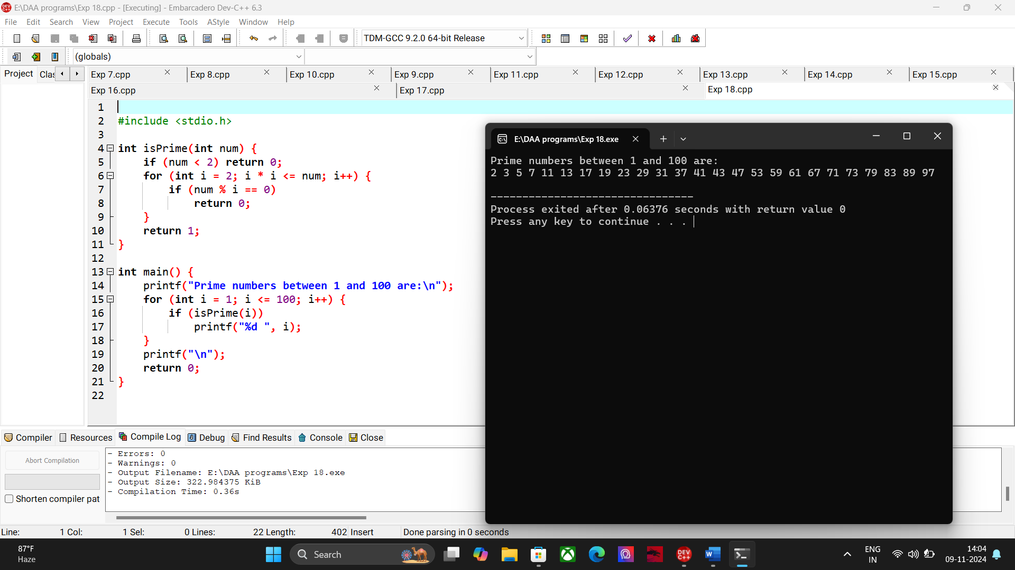

19. Perform Knapsack Problem Using Greedy Technique  
  
#include <stdio.h>

struct Item {

int value;

int weight;

};

void knapsack(int W, struct Item items[], int n) {

double ratio[n];

for (int i = 0; i < n; i++) {

ratio[i] = (double)items[i].value / items[i].weight;

}

for (int i = 0; i < n - 1; i++) {

for (int j = 0; j < n - i - 1; j++) {

if (ratio[j] < ratio[j + 1]) {

double tempRatio = ratio[j];

ratio[j] = ratio[j + 1];

ratio[j + 1] = tempRatio;

struct Item tempItem = items[j];

items[j] = items[j + 1];

items[j + 1] = tempItem;

}

}

}

int currentWeight = 0;

double totalValue = 0.0;

for (int i = 0; i < n; i++) {

if (currentWeight + items[i].weight <= W) {

currentWeight += items[i].weight;

totalValue += items[i].value;

} else {

int remain = W - currentWeight;

totalValue += items[i].value * ((double)remain / items[i].weight);

break;

}

}

printf("Maximum value in Knapsack = %.2f\n", totalValue);

}

int main() {

int W = 50;

struct Item items[] = {{60, 10}, {100, 20}, {120, 30}};

int n = sizeof(items) / sizeof(items[0]);

knapsack(W, items, n);

return 0;

}

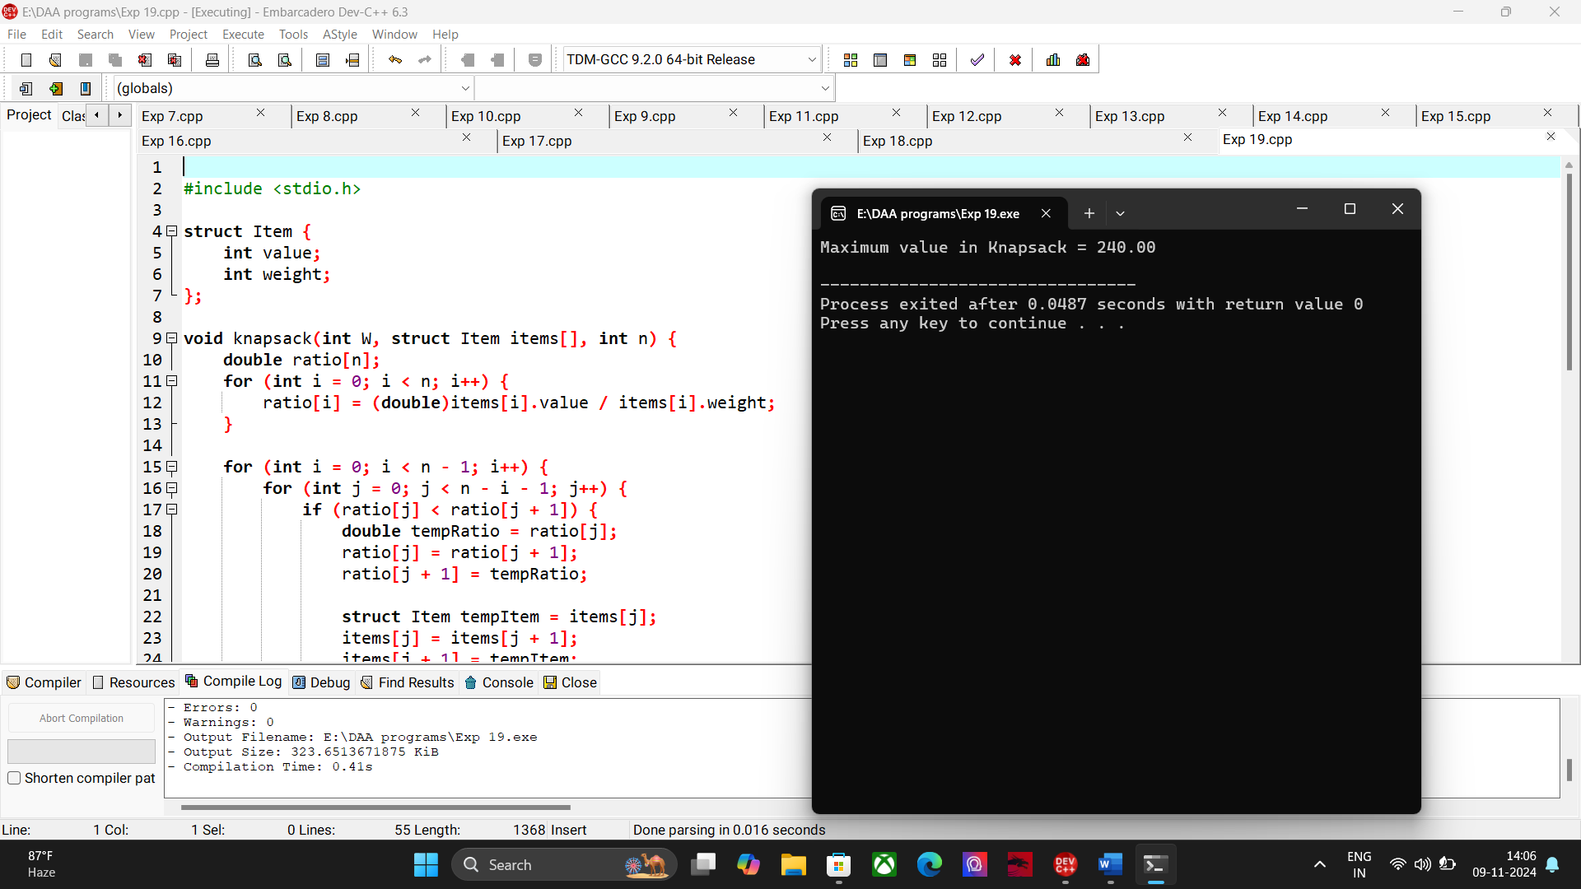

**20. MST using Greedy technique**

#include <stdio.h>

#include <stdlib.h>

#define MAX 100

struct Edge {

int src, dest, weight;

};

struct Graph {

int V, E;

struct Edge* edge;

};

struct Graph* createGraph(int V, int E) {

struct Graph* graph = (struct Graph*) malloc(sizeof(struct Graph));

graph->V = V;

graph->E = E;

graph->edge = (struct Edge*) malloc(graph->E * sizeof(struct Edge));

return graph;

}

struct Subset {

int parent;

int rank;

};

int find(struct Subset subsets[], int i) {

if (subsets[i].parent != i)

subsets[i].parent = find(subsets, subsets[i].parent);

return subsets[i].parent;

}

void Union(struct Subset subsets[], int x, int y) {

int xroot = find(subsets, x);

int yroot = find(subsets, y);

if (subsets[xroot].rank < subsets[yroot].rank)

subsets[xroot].parent = yroot;

else if (subsets[xroot].rank > subsets[yroot].rank)

subsets[yroot].parent = xroot;

else {

subsets[yroot].parent = xroot;

subsets[xroot].rank++;

}

}

int compareEdges(const void* a, const void* b) {

struct Edge* edgeA = (struct Edge*) a;

struct Edge* edgeB = (struct Edge*) b;

return edgeA->weight > edgeB->weight;

}

void kruskalMST(struct Graph* graph) {

int V = graph->V;

struct Edge result[MAX];

int e = 0;

int i = 0;

qsort(graph->edge, graph->E, sizeof(graph->edge[0]), compareEdges);

struct Subset* subsets = (struct Subset*) malloc(V * sizeof(struct Subset));

for (int v = 0; v < V; ++v) {

subsets[v].parent = v;

subsets[v].rank = 0;

}

while (e < V - 1 && i < graph->E) {

struct Edge nextEdge = graph->edge[i++];

int x = find(subsets, nextEdge.src);

int y = find(subsets, nextEdge.dest);

if (x != y) {

result[e++] = nextEdge;

Union(subsets, x, y);

}

}

printf("Edges in the Minimum Spanning Tree:\n");

for (i = 0; i < e; ++i)

printf("%d -- %d == %d\n", result[i].src, result[i].dest, result[i].weight);

free(subsets);

}

int main() {

int V = 4;

int E = 5;

struct Graph* graph = createGraph(V, E);

graph->edge[0].src = 0;

graph->edge[0].dest = 1;

graph->edge[0].weight = 10;

graph->edge[1].src = 0;

graph->edge[1].dest = 2;

graph->edge[1].weight = 6;

graph->edge[2].src = 0;

graph->edge[2].dest = 3;

graph->edge[2].weight = 5;

graph->edge[3].src = 1;

graph->edge[3].dest = 3;

graph->edge[3].weight = 15;

graph->edge[4].src = 2;

graph->edge[4].dest = 3;

graph->edge[4].weight = 4;

kruskalMST(graph);

free(graph->edge);

free(graph);

return 0;

}

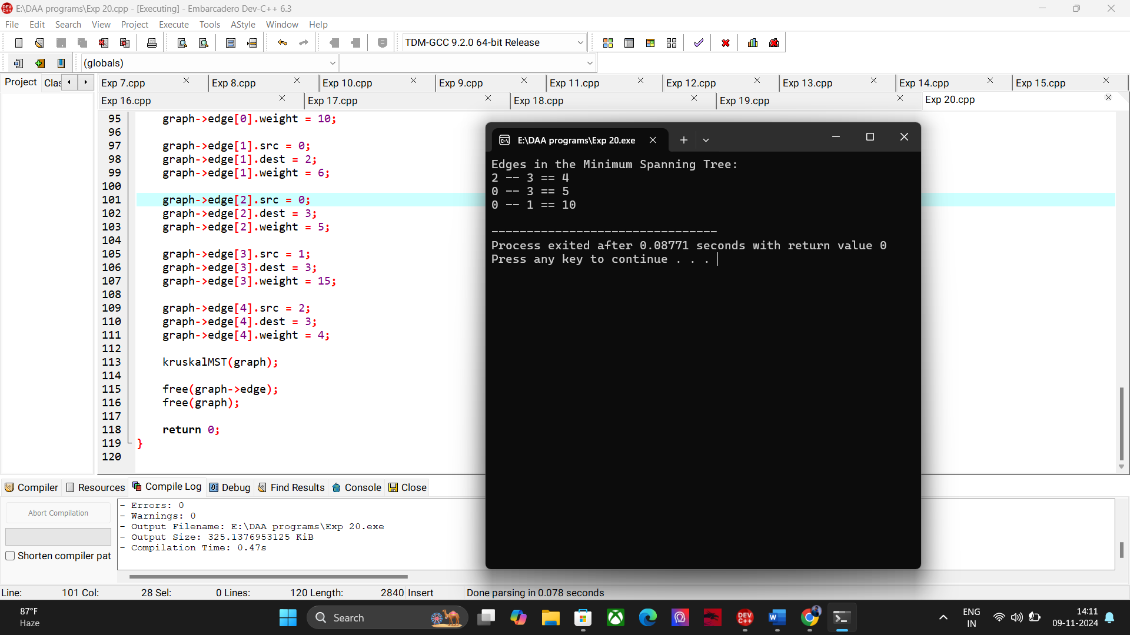

**21. Dynamic programming concept to find out OBST**

#include <stdio.h>

#include <limits.h>

int sum(int freq[], int i, int j) {

int s = 0;

for (int k = i; k <= j; k++)

s += freq[k];

return s;

}

int optimalBST(int keys[], int freq[], int n) {

int cost[n][n];

for (int i = 0; i < n; i++)

cost[i][i] = freq[i];

for (int len = 2; len <= n; len++) {

for (int i = 0; i <= n - len + 1; i++) {

int j = i + len - 1;

cost[i][j] = INT_MAX;

for (int r = i; r <= j; r++) {

int c = ((r > i) ? cost[i][r - 1] : 0) +

((r < j) ? cost[r + 1][j] : 0) +

sum(freq, i, j);

if (c < cost[i][j])

cost[i][j] = c;

}

}

}

return cost[0][n - 1];

}

int main() {

int keys[] = {10, 12, 20};

int freq[] = {34, 8, 50};

int n = sizeof(keys) / sizeof(keys[0]);

printf("Cost of Optimal BST is %d\n", optimalBST(keys, freq, n));

return 0;

}

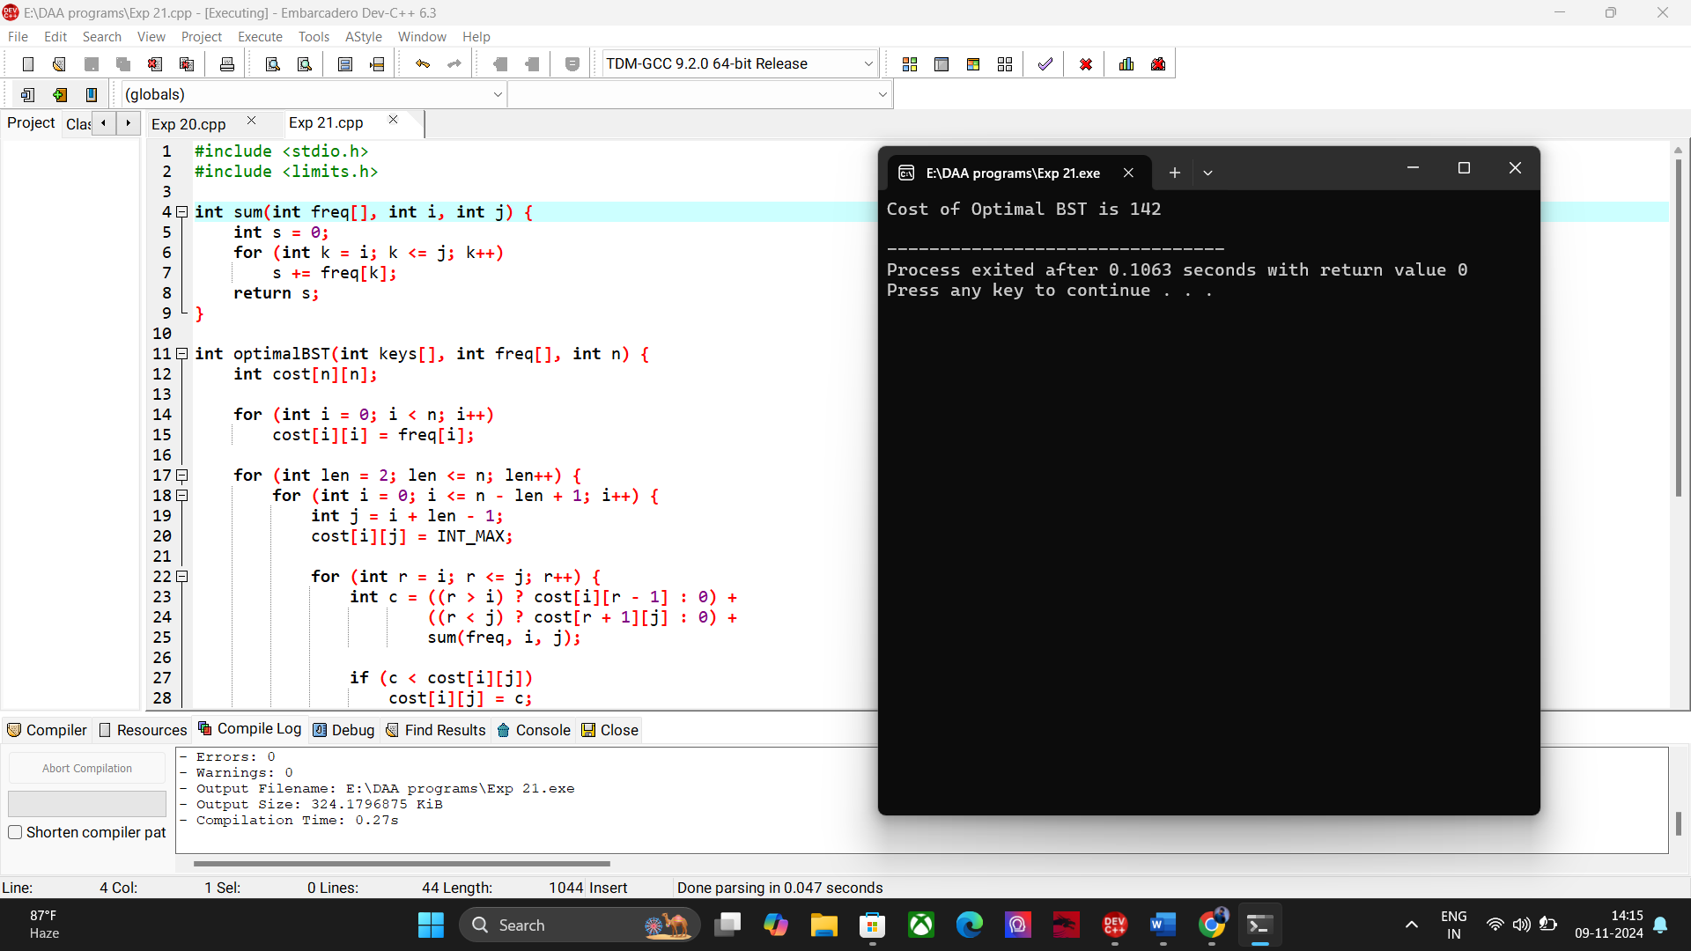

**22. Dynamic programming concept to find out Binomial Co-efficient of a given number.**

#include <stdio.h>

int binomialCoeff(int n, int k) {

int C[n + 1][k + 1];

for (int i = 0; i <= n; i++) {

for (int j = 0; j <= (i < k ? i : k); j++) {

if (j == 0 || j == i)

C[i][j] = 1;

else

C[i][j] = C[i - 1][j - 1] + C[i - 1][j];

}

}

return C[n][k];

}

int main() {

int n = 5, k = 2;

printf("Binomial Coefficient C(%d, %d) is %d\n", n, k, binomialCoeff(n, k));

return 0;

}

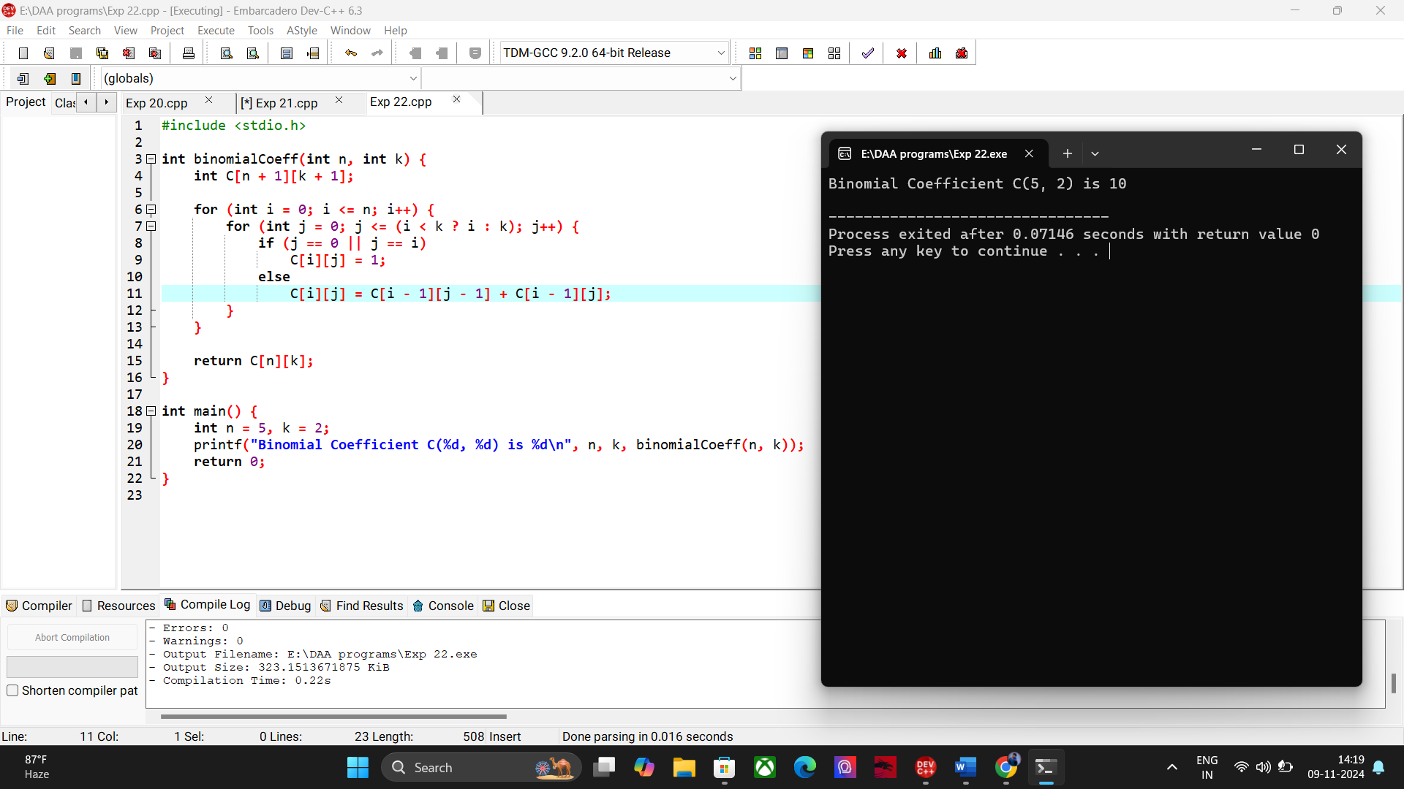

**23. Reverse of a given number.**

#include <stdio.h>

int reverseNumber(int num) {

int reversed = 0;

while (num != 0) {

int lastDigit = num % 10;

reversed = reversed * 10 + lastDigit;

num /= 10;

}

return reversed;

}

int main() {

int number;

printf("Enter an integer: ");

scanf("%d", &number);

int reversed = reverseNumber(number);

printf("Reversed number: %d\n", reversed);

return 0;

}

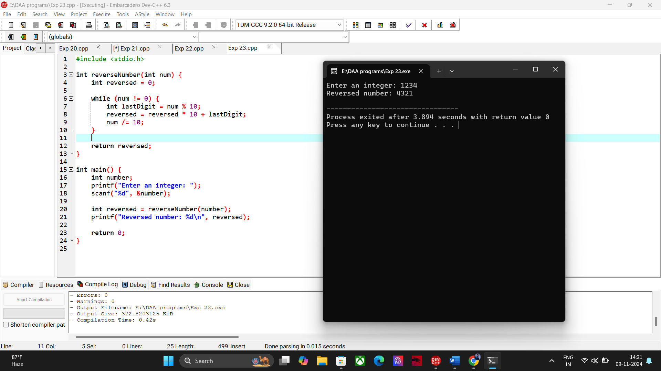

**24. Perfect Number.**

#include <stdio.h>

int isPerfect(int num) {

int sum = 0;

for (int i = 1; i <= num / 2; i++) {

if (num % i == 0) {

sum += i;

}

}

return sum == num;

}

int main() {

int number;

printf("Enter a number: ");

scanf("%d", &number);

if (isPerfect(number)) {

printf("%d is a perfect number.\n", number);

} else {

printf("%d is not a perfect number.\n", number);

}

return 0;

}

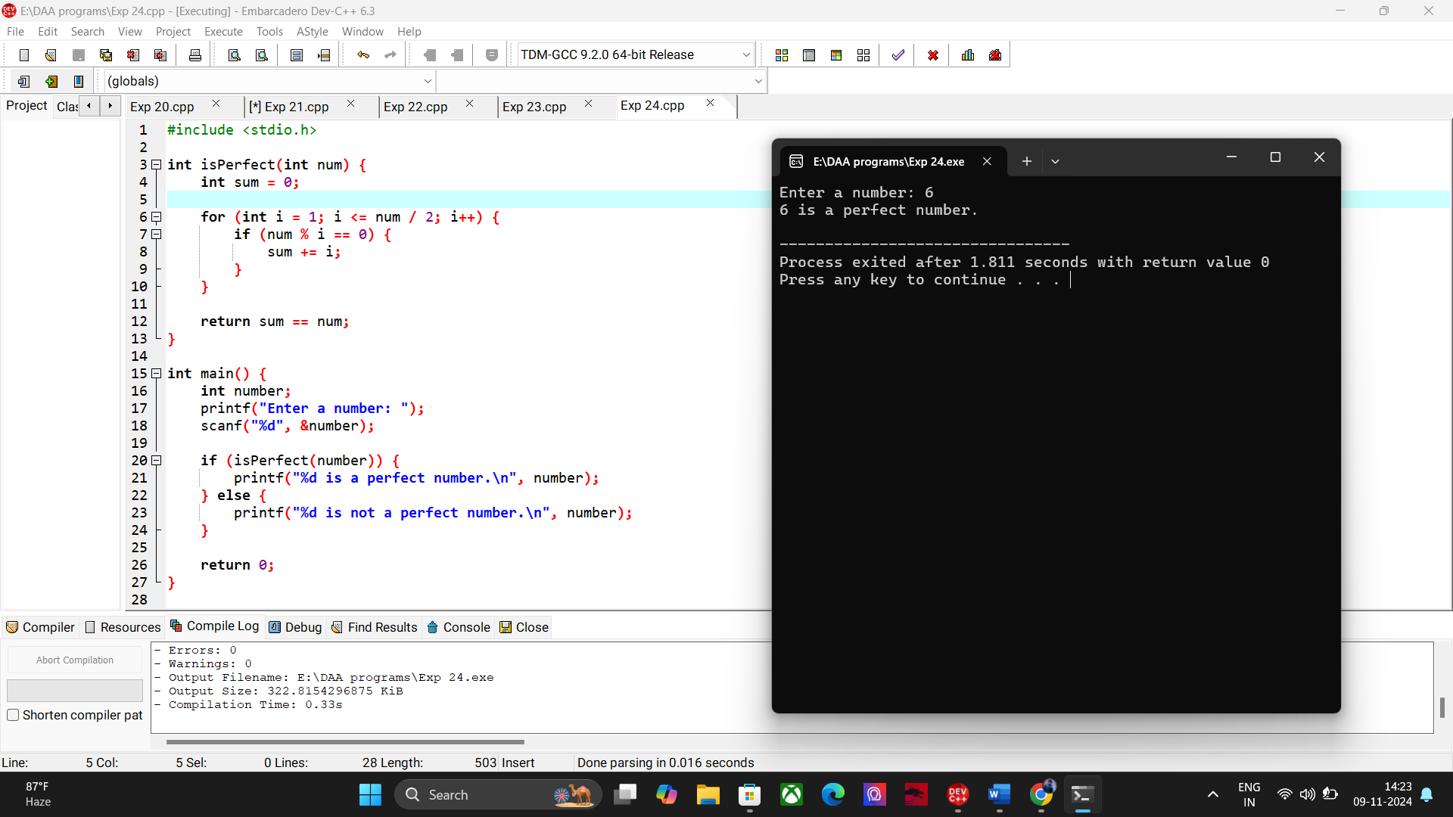

**25. TSP Using Dynamic Programming.**

#include <stdio.h>

#include <limits.h>

#define N 4

#define INF INT_MAX

int cost[N][N] = {

{0, 20, 42, 35},

{20, 0, 30, 34},

{42, 30, 0, 12},

{35, 34, 12, 0}

};

int dp[1 << N][N];

int tsp(int mask, int pos) {

if (mask == ((1 << N) - 1))

return cost[pos][0];

if (dp[mask][pos] != -1)

return dp[mask][pos];

int ans = INF;

for (int city = 0; city < N; city++) {

if ((mask & (1 << city)) == 0) {

int newAns = cost[pos][city] + tsp(mask | (1 << city), city);

ans = (ans < newAns) ? ans : newAns;

}

}

return dp[mask][pos] = ans;

}

int main() {

for (int i = 0; i < (1 << N); i++)

for (int j = 0; j < N; j++)

dp[i][j] = -1;

int result = tsp(1, 0);

printf("The minimum cost of visiting all cities is: %d\n", result);

return 0;

}

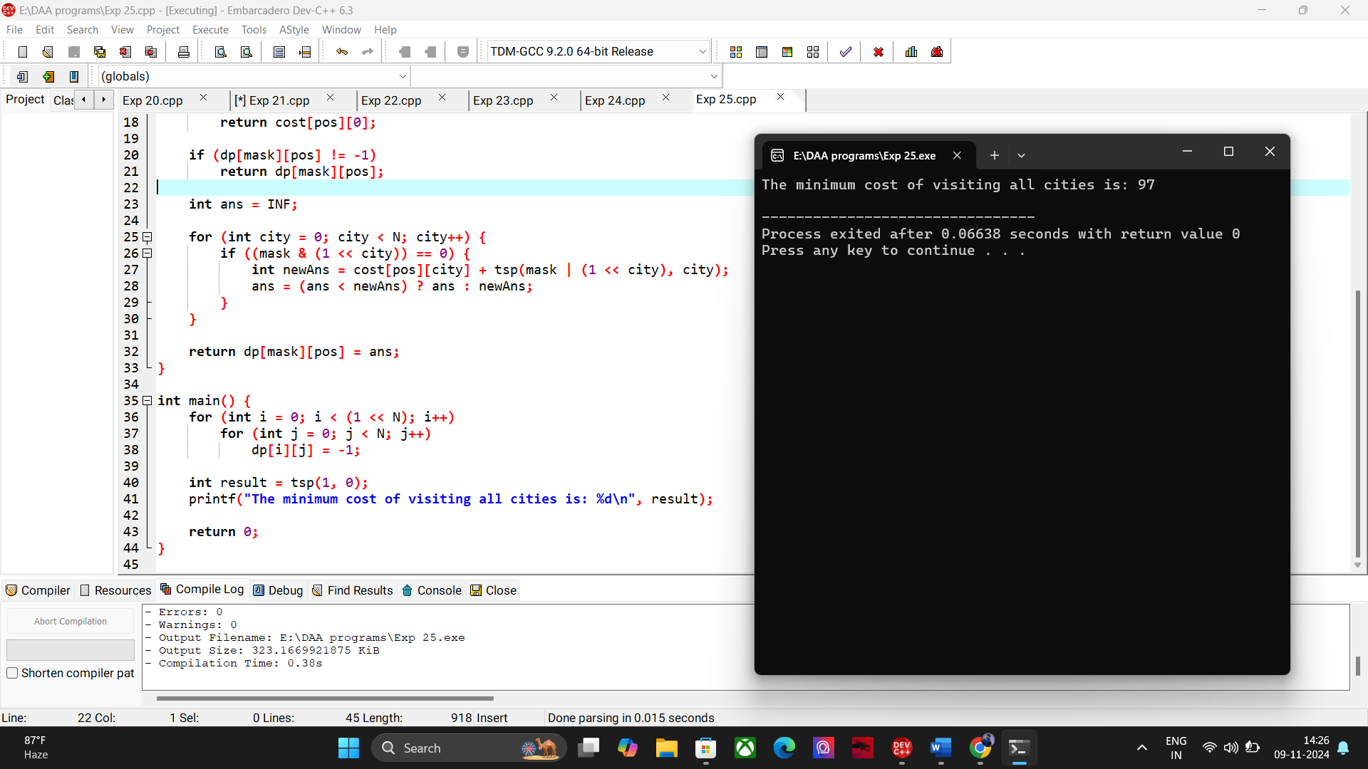

**26. Numeric Pattern program**

#include <stdio.h>

int main() {

int n = 4;

for (int i = 1; i <= n; i++) {

for (int j = 1; j <= i; j++) {

printf("%d ", j);

}

printf("\n");

}

return 0;

}

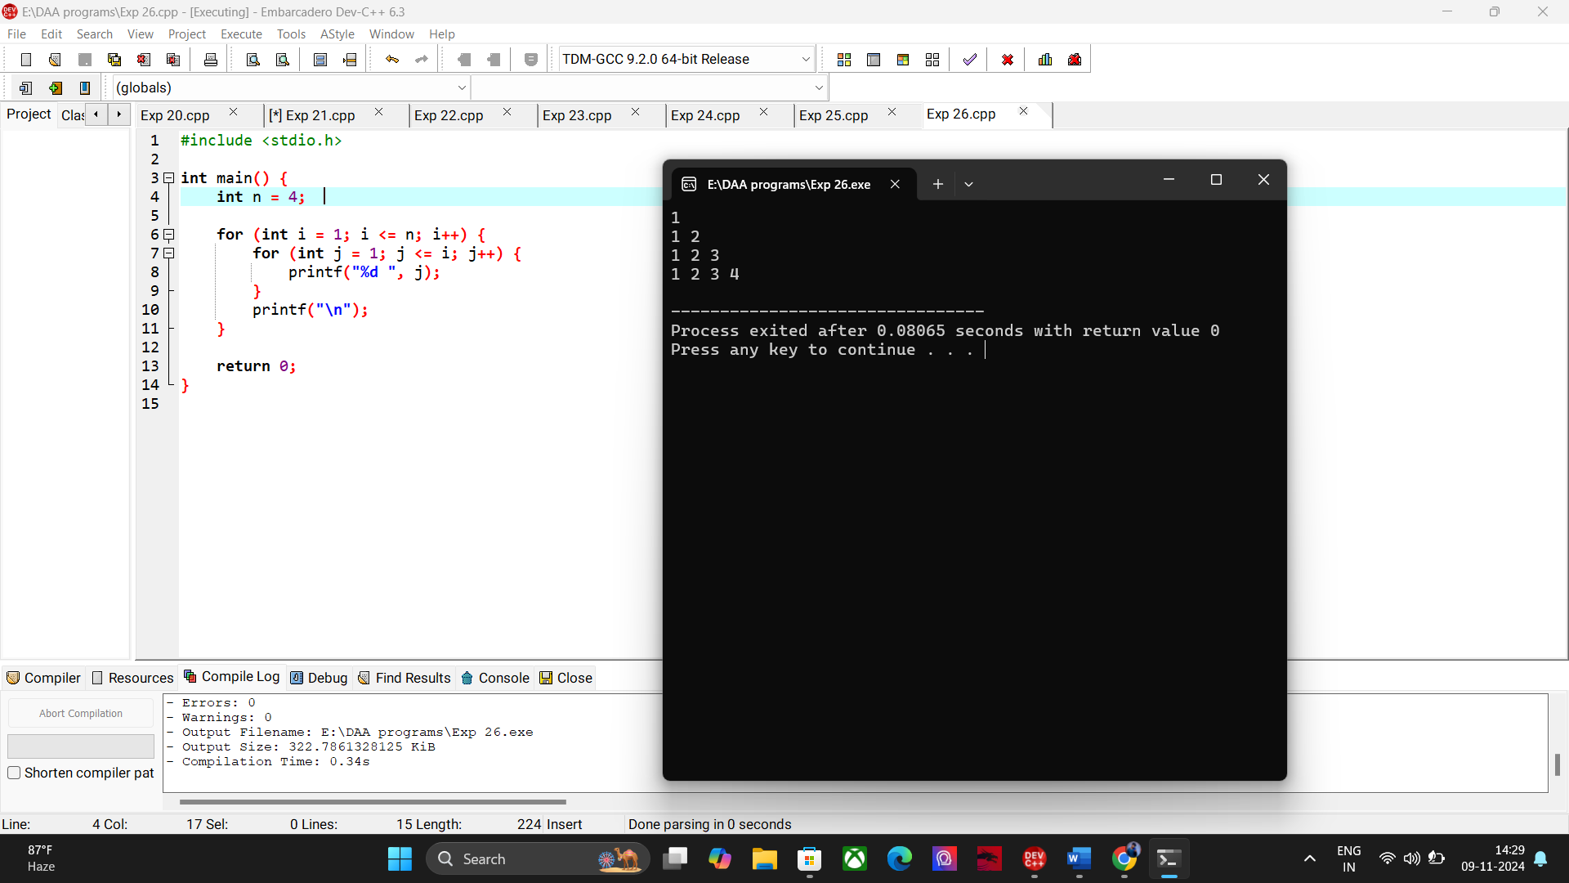

**27. Perform Floyd’s Algorithm.**

#include <stdio.h>

#define INF 99999

#define V 4

void printSolution(int dist[V][V]) {

printf("Shortest distances between every pair of vertices:\n");

for (int i = 0; i < V; i++) {

for (int j = 0; j < V; j++) {

if (dist[i][j] == INF)

printf("%4s ", "INF");

else

printf("%4d ", dist[i][j]);

}

printf("\n");

}

}

void floydWarshall(int graph[V][V]) {

int dist[V][V];

for (int i = 0; i < V; i++)

for (int j = 0; j < V; j++)

dist[i][j] = graph[i][j];

for (int k = 0; k < V; k++) {

for (int i = 0; i < V; i++) {

for (int j = 0; j < V; j++) {

if (dist[i][k] != INF && dist[k][j] != INF && dist[i][j] > dist[i][k] + dist[k][j]) {

dist[i][j] = dist[i][k] + dist[k][j];

}

}

}

}

printSolution(dist);

}

int main() {

int graph[V][V] = {

{0, 3, INF, 5},

{2, 0, INF, 4},

{INF, 1, 0, INF},

{INF, INF, 2, 0}

};

floydWarshall(graph);

return 0;

} 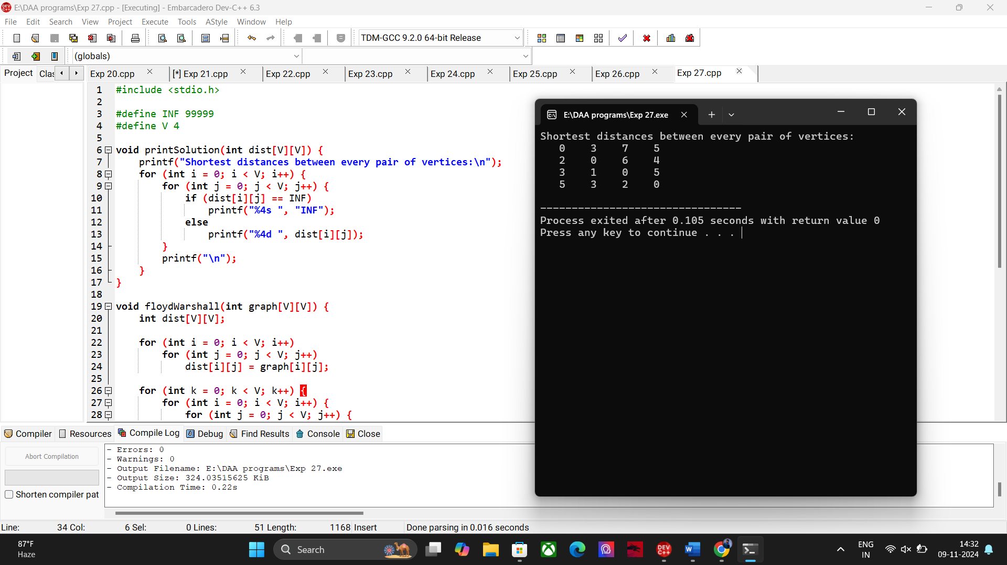

**28. Pascal Triangle**

#include <stdio.h>

int factorial(int n) {

int result = 1;

for (int i = 1; i <= n; i++)

result *= i;

return result;

}

int binomialCoeff(int n, int k) {

return factorial(n) / (factorial(k) * factorial(n - k));

}

void printPascalsTriangle(int n) {

for (int i = 0; i < n; i++) {

for (int j = 0; j < n - i - 1; j++) {

printf(" ");

}

for (int j = 0; j <= i; j++) {

printf("%4d", binomialCoeff(i, j));

}

printf("\n");

}

}

int main() {

int rows;

printf("Enter the number of rows for Pascal's Triangle: ");

scanf("%d", &rows);

printPascalsTriangle(rows);

return 0;

}

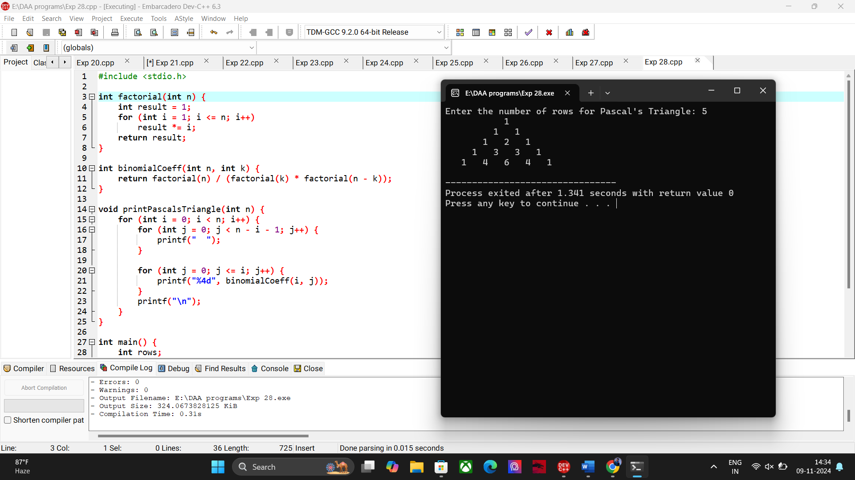

**29. Sum Of the digits.**

#include <stdio.h>

int sumOfDigits(int num) {

int sum = 0;

while (num != 0) {

sum += num % 10;

num /= 10;

}

return sum;

}

int main() {

int number;

printf("Enter an integer: ");

scanf("%d", &number);

int result = sumOfDigits(number);

printf("Sum of the digits: %d\n", result);

return 0;

}

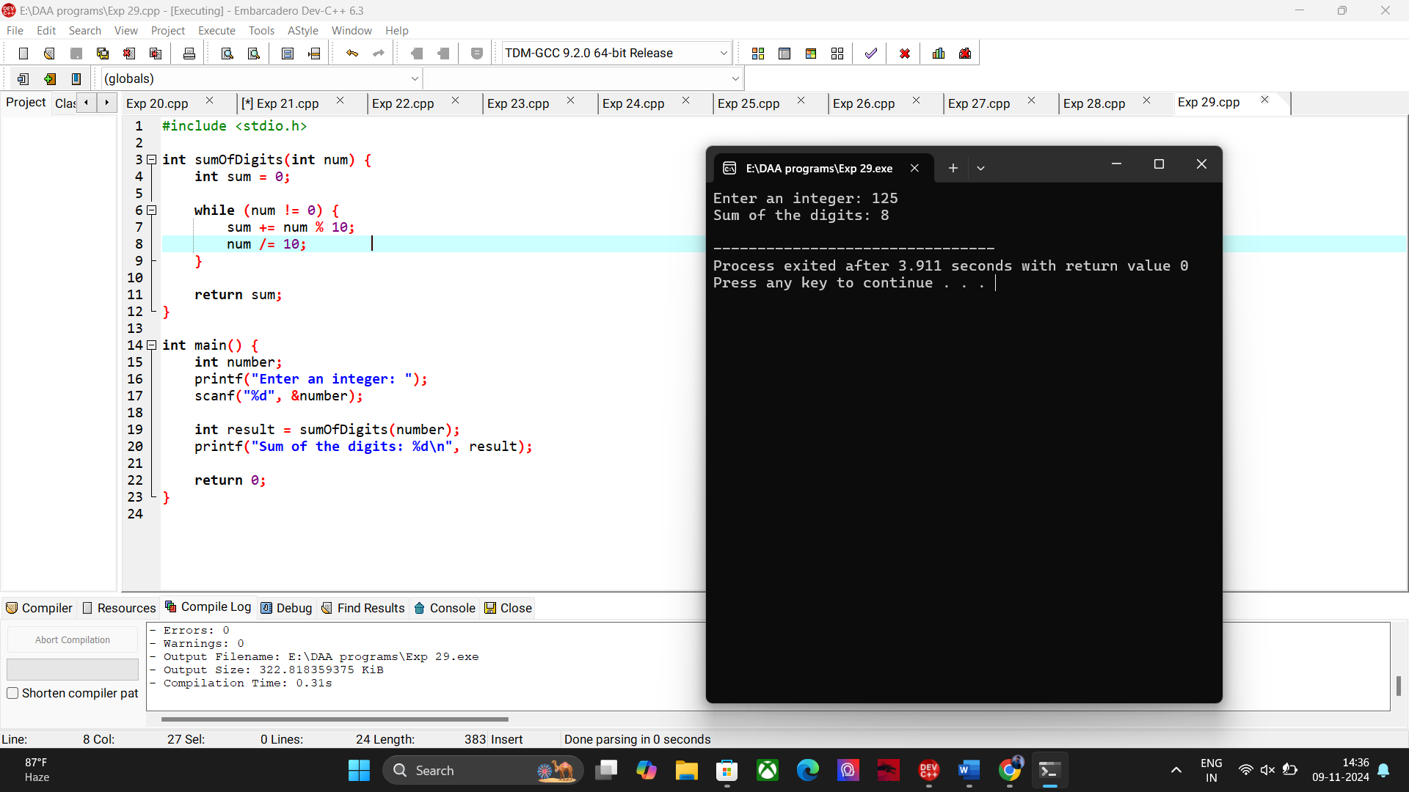

**30. Inserting a number in a list.**

#include <stdio.h>

#define MAX_SIZE 100

void insertElement(int arr[], int *size, int num, int position) {

if (position < 0 || position > *size) {

printf("Invalid position.\n");

return;

}

for (int i = *size; i > position; i--) {

arr[i] = arr[i - 1];

}

arr[position] = num;

(*size)++;

}

void displayArray(int arr[], int size) {

for (int i = 0; i < size; i++) {

printf("%d ", arr[i]);

}

printf("\n");

}

int main() {

int arr[MAX_SIZE];

int size = 0;

int num, position;

printf("Enter the number of elements in the list: ");

scanf("%d", &size);

printf("Enter the elements:\n");

for (int i = 0; i < size; i++) {

scanf("%d", &arr[i]);

}

printf("Enter the number to insert: ");

scanf("%d", &num);

printf("Enter the position to insert the number (0-based index): ");

scanf("%d", &position);

insertElement(arr, &size, num, position);

printf("Updated list: ");

displayArray(arr, size);

return 0;

}

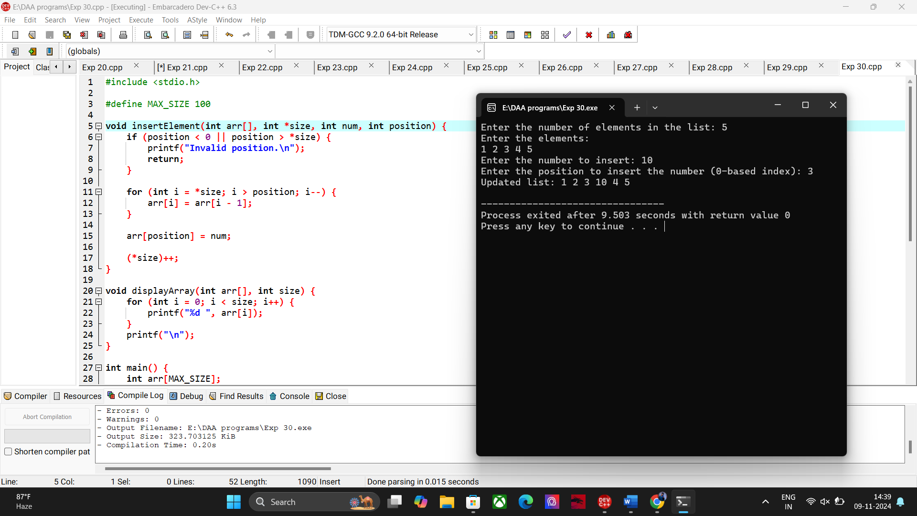

**31.SUM OF SUBSETS USING BACKTRACKING**

#include <stdio.h>

void subsetSum(int arr[], int n, int target_sum, int index, int current_sum, int current_subset[], int subset_size) { if (current_sum == target_sum) {

printf("{ "); for (int i = 0; i < subset_size; i++) { printf("%d ", current_subset[i]);

}

printf("}\n"); return;

}

if (current_sum > target_sum || index == n) {

return;

}

current_subset[subset_size] = arr[index];

subsetSum(arr, n, target_sum, index + 1, current_sum + arr[index], current_subset, subset_size +

1); subsetSum(arr, n, target_sum, index + 1, current_sum, current_subset, subset_size);

}

void findAllSubsets(int arr[], int n, int target_sum) { int current_subset[n]; subsetSum(arr, n, target_sum, 0, 0, current_subset, 0);

}

int main() { int arr[] = {10, 7, 5, 18, 12, 20, 15}; int target_sum = 35; int n = sizeof(arr) / sizeof(arr[0]);

printf("Subsets with sum %d are:\n", target_sum); findAllSubsets(arr, n, target_sum); return 0;

}

**OUTPUT:**

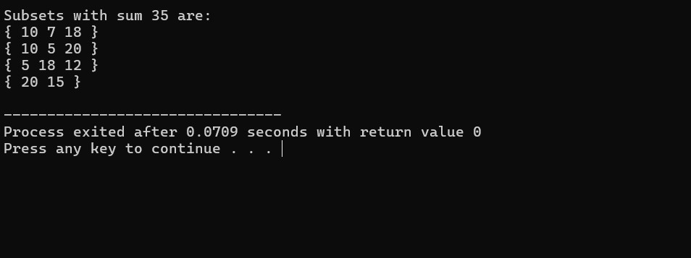

**32.GRAPH COLOURING USING BACKTRACKING**

#include <stdio.h>

#include <stdbool.h>

#define N 4 bool isSafe(int vertex, int graph[N][N], int colors[], int color) { for (int i = 0; i < N; i++) { if (graph[vertex][i] && colors[i] == color) { return false;

}

}

return true;

}

bool graphColoring(int graph[N][N], int m, int colors[], int vertex) {

if (vertex == N) { return true;

}

for (int color = 1; color <= m; color++) { if (isSafe(vertex, graph, colors, color)) { colors[vertex] = color; if (graphColoring(graph, m, colors, vertex + 1)) {

return true;

}

colors[vertex] = 0;

}

}

return false;

}

void solveGraphColoring(int graph[N][N], int m) {

int colors[N] = {0}; if (graphColoring(graph, m, colors, 0)) { printf("Solution found:\n"); for (int i = 0; i < N; i++) { printf("Vertex %d -> Color %d\n", i, colors[i]);

}

} else {

printf("No solution exists\n");

}

}

int main() { int graph[N][N] = {

{0, 1, 1, 1},

{1, 0, 1, 0},

{1, 1, 0, 1},

{1, 0, 1, 0}

};

int m = 3;

solveGraphColoring(graph, m);

return 0;

}

**OUTPUT:**

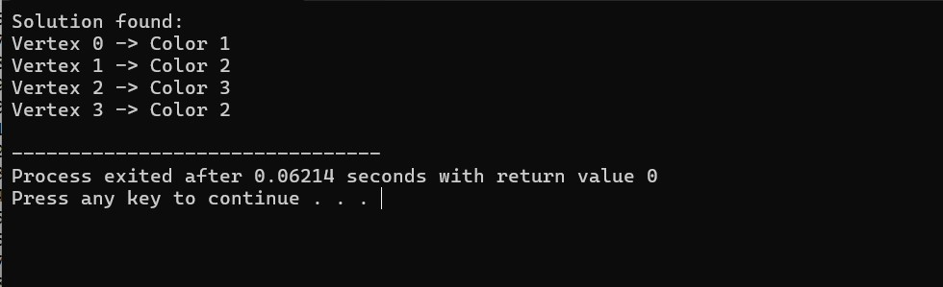

**33.CONTAINER LOADING PROBLEM**

#include <stdio.h> int maxLoad = 0; void backtrack(int weights[], int n, int capacity, int index, int currentLoad) { if (currentLoad > capacity) {

return;

}

if (currentLoad > maxLoad) { maxLoad = currentLoad; }

if (index == n) { return;

}

backtrack(weights, n, capacity, index + 1, currentLoad + weights[index]); backtrack(weights, n, capacity, index + 1, currentLoad);

}

int maxContainerLoad(int weights[], int n, int capacity) { maxLoad = 0; backtrack(weights, n, capacity, 0, 0); return maxLoad;

}

int main() { int weights[] = {10, 20, 30, 40}; int n = sizeof(weights) / sizeof(weights[0]); int capacity = 50; int maxLoadPossible = maxContainerLoad(weights, n, capacity); printf("Maximum load that can be loaded: %d\n", maxLoadPossible);

return 0;

}

**OUTPUT:**

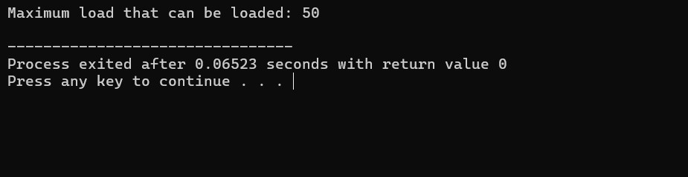

**34.LIST OF ALL FACTORS FOR N VALUE** #include <stdio.h> #include <math.h>

void findFactors(int n) { printf("Factors of %d are:\n", n); for (int i = 1; i <= sqrt(n); i++) {

if (n % i == 0) { printf("%d ", i); if (i != n / i) { printf("%d ", n / i);

}

}

}

printf("\n");

}

int main() {

int n;

printf("Enter a number to find its factors: "); scanf("%d", &n); findFactors(n); return 0;

}

**OUTPUT:**

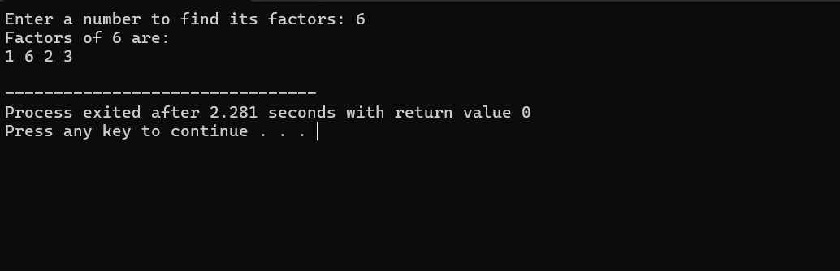

**35.JOB ASSIGNMENT PROBLEM USING BRANCH AND BOUND**

#include <stdio.h>

#include <limits.h>

#include <stdbool.h>

#define N 4

typedef struct Node {

int cost; int lowerBound; int jobAssignment[N]; bool assigned[N];

int level;

} Node; int calculateLowerBound(int costMatrix[N][N], bool assigned[N], int level) { int lowerBound = 0;

for (int i = level; i < N; i++) { int minCost = INT_MAX;

for (int j = 0; j < N; j++) {

if (!assigned[j] && costMatrix[i][j] < minCost) { minCost = costMatrix[i][j];

}

}

lowerBound += minCost;

}

return lowerBound;

}

void branchAndBound(int costMatrix[N][N]) { int minCost = INT_MAX;

Node bestNode; Node root; root.cost = 0; root.level = 0; for (int i = 0; i < N; i++) { root.assigned[i] = false; root.jobAssignment[i] = -1;

}

root.lowerBound = calculateLowerBound(costMatrix, root.assigned, root.level); Node queue[N * N]; int queueSize = 0; queue[queueSize++] = root; while (queueSize > 0) {

Node currentNode = queue[--queueSize]; if (currentNode.lowerBound >= minCost) continue;

if (currentNode.level == N) { if (currentNode.cost < minCost) { minCost = currentNode.cost; bestNode = currentNode;

}

continue;

}

for (int job = 0; job < N; job++) { if (!currentNode.assigned[job]) { Node newNode = currentNode; newNode.level++; newNode.jobAssignment[currentNode.level - 1] = job; newNode.cost += costMatrix[currentNode.level - 1][job]; newNode.assigned[job] = true;

newNode.lowerBound = newNode.cost + calculateLowerBound(costMatrix, newNode.assigned, newNode.level);

if (newNode.lowerBound < minCost) { queue[queueSize++] = newNode;

}

}

}

}

printf("Minimum cost: %d\n", minCost); printf("Job assignments:\n");

for (int i = 0; i < N; i++) {

printf("Person %d -> Job %d\n", i, bestNode.jobAssignment[i]);

}

}

int main() { int costMatrix[N][N] = {

{9, 2, 7, 8},

{6, 4, 3, 7},

{5, 8, 1, 8},

{7, 6, 9, 4}

};

branchAndBound(costMatrix);

return 0;

}

**OUTPUT:**

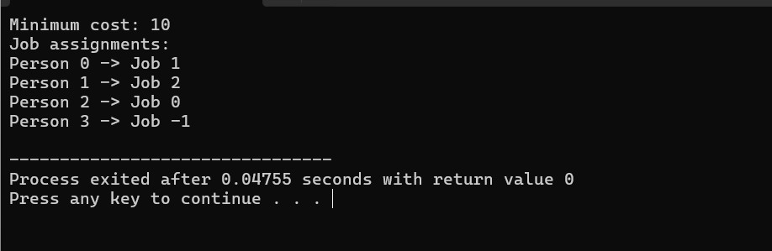

**36.LINEAR SEARCH** #include <stdio.h>

int linearSearch(int arr[], int n, int target) { for (int i = 0; i < n; i++) { if (arr[i] == target) { return i;

}

}

return -1;

}

int main() { int arr[] = {34, 21, 56, 78, 90, 23, 12}; int n = sizeof(arr) / sizeof(arr[0]); int target = 78; int result = linearSearch(arr, n, target); if (result != -1) {

printf("Element found at index %d\n", result);

} else { printf("Element not found in the array\n");

}

return 0;

}

**OUTPUT:**

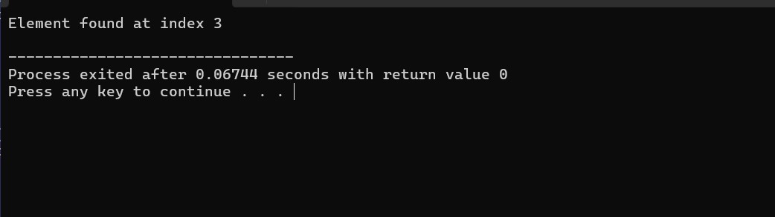

**37.HAMILTONIAN CIRCUIT USING BACKTRACKING** #include <stdio.h>

#include <stdbool.h> #define V 5 bool canAddToPath(int v, int graph[V][V], int path[], int position) { if (graph[path[position - 1]][v] == 0) return false; for (int i = 0; i < position; i++) { if (path[i] == v)

return false;

}

return true;

}

bool hamiltonianCycle(int graph[V][V], int path[], int position) {

if (position == V) { if (graph[path[position - 1]][path[0]] == 1)

return true; else return false;

}

for (int v = 1; v < V; v++) { if (canAddToPath(v, graph, path, position)) { path[position] = v; if (hamiltonianCycle(graph, path, position + 1))

return true; path[position] = -1;

}

}

return false;

}

int main() { int graph[V][V] = {

{0, 1, 0, 1, 0},

{1, 0, 1, 1, 0},

{0, 1, 0, 1, 1},

{1, 1, 1, 0, 1},

{0, 0, 1, 1, 0}

};

int path[V]; for (int i = 0; i < V; i++) { path[i] = -1;

}

path[0] = 0; if (hamiltonianCycle(graph, path, 1)) { printf("Hamiltonian Cycle found: \n");

for (int i = 0; i < V; i++) { printf("%d ", path[i]);

}

printf("%d\n", path[0]);

} else {

printf("No Hamiltonian Cycle found\n");

}

return 0;

}

**OUTPUT:**

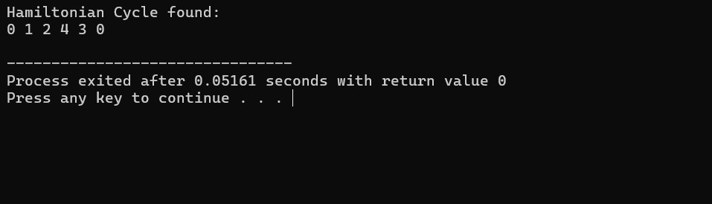

**38.N QUEENS PROBLEM**

#include <stdio.h>

#include <stdbool.h> #define N 8 int board[N][N]; void printSolution() {

for (int i = 0; i < N; i++) { for (int j = 0; j < N; j++) { if (board[i][j] == 1) printf(" Q "); else printf(" . ");

}

printf("\n");

}

printf("\n");

}

bool isSafe(int row, int col) { for (int i = 0; i < row; i++) { if (board[i][col] == 1) return false;

}

for (int i = row, j = col; i >= 0 && j >= 0; i--, j--) { if (board[i][j] == 1) return false;

}

for (int i = row, j = col; i >= 0 && j < N; i--, j++) { if (board[i][j] == 1) return false;

}

return true;

}

bool solveNQueens(int row) {

if (row == N) return true; for (int col = 0; col < N; col++) { if (isSafe(row, col)) { board[row][col] = 1; if (solveNQueens(row + 1))

return true; board[row][col] = 0;

}

}

return false;

}

int main() {

for (int i = 0; i < N; i++) for (int j = 0; j < N; j++) board[i][j] = 0; if (solveNQueens(0)) {

printSolution();

} else { printf("No solution exists\n");

}

return 0;

}

**OUTPUT:**

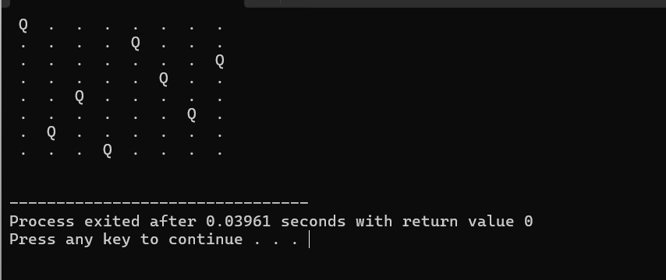

**39.OPTIMAL COST BY USING APPROPRIATE ALGORITHM** #include <stdio.h>

#include <limits.h>

#include <stdbool.h>

#define V 5

#define INF INT_MAX

void dijkstra(int graph[V][V], int src) {

int dist[V];

bool sptSet[V];

for (int i = 0; i < V; i++) { dist[i] = INF; sptSet[i] = false;

}

dist[src] = 0; for (int count = 0; count < V - 1; count++) {

int u = -1; for (int v = 0; v < V; v++) { if (!sptSet[v] && (u == -1 || dist[v] < dist[u])) {

u = v;

}

}

sptSet[u] = true; for (int v = 0; v < V; v++) { if (graph[u][v] && !sptSet[v] && dist[u] != INF && dist[u] + graph[u][v] < dist[v]) { dist[v] = dist[u] + graph[u][v];

}

}

}

printf("Vertex\tDistance from Source\n");

for (int i = 0; i < V; i++) { printf("%d\t%d\n", i, dist[i]);

}

}

int main() { int graph[V][V] = { {0, 10, 0, 30, 0},

{10, 0, 50, 0, 0},

{0, 50, 0, 20, 10},

{30, 0, 20, 0, 60},

{0, 0, 10, 60, 0}

};

dijkstra(graph, 0);

return 0;

}

**OUTPUT:**

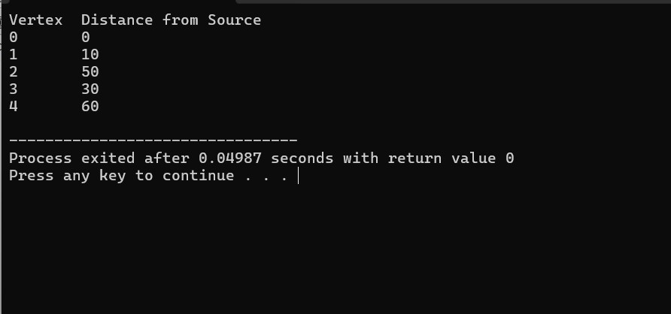

**40.MIN MAX VALUE SEPERATELY FOR ALL NUMBERS IN THE LIST** #include <stdio.h> void findMinMax(int numbers[], int size, int* min, int* max) {

*min = numbers[0]; *max = numbers[0];

for (int i = 1; i < size; i++) { if (numbers[i] < *min) {

*min = numbers[i];

}

if (numbers[i] > *max) {

*max = numbers[i];

}

}

}

int main() { int numbers[] = {34, 21, 56, 78, 90, 23, 12}; int size = sizeof(numbers) / sizeof(numbers[0]); int min, max;

findMinMax(numbers, size, &min, &max); printf("Minimum value: %d\n", min); printf("Maximum value: %d\n", max);

return 0;

}

**OUTPUT:**

